+ 
AMITY UNIVERSITY ONLINE, NOIDA, UTTAR PRADESH

In partial fulfillment of the requirement for the award of degree of
Master of Business Administration
(IT Management)

TITLE: Utilizing Artificial Intelligence in IT Recruitment: Enhancing Efficiency and Effectiveness

Guide Details:
Name of Mentor: Deepti Gupta

Submitted By:

Name of the Student: Desala Likhitha Mahalaxmi
Enrollment No: A9920124022429(el)

DECLARATION
I, Desala Likhitha Maha laxmi, a student pursuing MBA (IT Management) 4th year at Amity University Online, hereby declare that the project work entitled “Utilizing Artificial Intelligence in IT Recruitment: Enhancing Efficiency and Effectiveness” has been prepared by me during the academic year 2026 under the guidance of Deepti Gupta. I assert that this project is a piece of original bona-fide work done by me. It is the outcome of my own effort and that it has not been submitted to any other university for the award of any degree.

Signature of Student
Desala Likhitha Mahalaxmi

ABSTRACT

Artificial Intelligence (AI) is transforming recruitment processes, especially in the IT sector where efficiency and accuracy are critical. This study examines the role of AI in enhancing recruitment effectiveness by automating sourcing, screening, and selection processes.

The research adopts a descriptive design using both primary and secondary data. Primary data is collected through surveys of HR professionals and job seekers. The findings indicate that AI significantly reduces hiring time, improves candidate matching, and enhances recruiter productivity.

However, challenges such as algorithm bias, high implementation cost, and lack of human interaction remain. The study concludes with recommendations for effective and sustainable integration of AI in IT recruitment.

TABLE OF CONTENTS
S. No. | Particulars | Page No.
i | List of Tables | vi
ii | List of Figures | vi
1 | Chapter 1: Introduction to the Topic | 1-14
1.1 | Overview of Recruitment | 1
1.2 | Importance of IT Recruitment | 2
1.3 | Challenges in Traditional Recruitment | 5
1.4 | Introduction to Artificial Intelligence in HR | 6
1.5 | Need for AI in Recruitment | 8
1.6 | Justification for Selection of This Topic | 10
1.7 | Scope of the Study | 11
1.8 | Objectives of the Study | 12
1.9 | Significance of the Study | 13
2 | Chapter 2: Review of Literature | 15-30
2.1 | Introduction to AI in Human Resource Management | 15
2.2 | AI Application in the Recruitment Lifecycle | 17
2.3 | Impact on Key recruitment Metrics | 20
2.4 | Challenges and Ethical Considerations | 24
2.6 | Research Gaps | 27
3 | Chapter 3: Research Objectives and Methodology | 31-61
3.1 | Research Objectives | 31
3.2 | Research Problem | 32
3.3 | Research Design | 34
3.4 | Type of Data Used | 37
3.5 | Data Collection Methods | 41
3.6 | Data Collection Instruments | 45
3.7 | Sample Size | 50
3.8 | Sampling Technique | 52
3.9 | Data Analysis Tools | 56
4 | Chapter 4: Data Analysis, Results and Interpretation | 62-80
4.1 | Demographic Profile of Respondents | 62
4.2 | Current State of IT Recruitment | 64
4.3 | AI Tool Adoption Patterns | 68
4.4 | Impact on Time-to-Fill | 72
4.5 | Impact on Cost-per-Hire | 74
4.6 | Impact on Quality of Hire | 76
4.7 | Challenges in AI Adoption | 78
5 | Chapter 5: Findings and Conclusion | 81-83
5.1 | Key Findings | 81
5.2 | Conclusion | 82
6 | Chapter 6: Recommendations and Limitations of the Study | 84-87
6.1 | Recommendations | 84
6.2 | Limitations of the Study | 86
7 | Chapter 7: Bibliography / References | 88-89
8 | Appendix | 90-91

LIST OF TABLES

S. No. | Particulars | Page No.
i | Table 1.2.1: Demand Level and Recruitment Difficulty Across IT Domains | 5
ii | Table 1.4.1.: Growth of AI in HR Technology Market (2018-2024) | 8
iii | Table 1.7.1: Scope of the Study | 12
iv | Table 1.9.1: Significance of AI-Based Recruitment for Key Stakeholders | 14
v | Table 2.1.1: AI Applications across HR Functions | 17
vi | Table 2.3.1: Impact of AI on Recruitment Performance Metrics | 23
vii | Table 2.4.1: Major Ethical Challenges in AI-Based Recruitment | 26
viii | Table 2.5.1: Review of Literature on AI in Recruitment and HRM | 37
ix | Table 3.3.1: Research methodology Components and Description | 20
x | Table 3.4.1: Primary Data Source | 40
xi | Table 3.4.2: Secondary data Source | 41
xii | Table 3.6.1 Structure of the Research Questionnaire | 49
xiii | Table 3.7.1: Distribution of Respondents by professional category | 52
xiv | Table 3.9.1: Statistical tools used for Research Data Analysis | 60
xv | Table 3.9.2: Structure of Research Questionnaire | 60
xvi | Table 3.9.3: Month-wise Schedule of Research Activities | 61
xvii | Table 4.1.1: Demographic Profile of Respondents | 64
xviii | Table 4.2.1: Baseline Recruitment Performance Metrics Before AI Adoption | 65
xix | Table 4.2.2: Key Recruitment Challenges in Traditional IT Recruitment Process | 68
xx | Table 4.3.1: Extent of AI Adoption among participating IT Organization | 70
xxi | Table 4.3.2: AI tools used across Recruitment Functions | 71
xxii | Table 4.3.3: Organizational Maturity Levels in AI Recruitment Adoption | 71

LIST OF FIGURES

S. No. | Particulars | Page No.
i | Figure 1.1.1: Recruitment Life Cycle Stages | 2
ii | Figure 1.2.1: Global Talent Shortage Over Time | 3
iii | Figure 1.4.1: AI in Hiring Process | 7
iv | Figure 1.5.1: Traditional vs AI-Driven Recruitment | 10
v | Figure 2.2.1: AI Recruitment Industry Leaders | 20
vi | Figure 2.3.1: AI Recruitment Market Size and Share | 24
vii | Figure 2.4.1: Ethical Risks in AI Recruitment | 25
viii | Figure 3.1.1: Conceptual Framework of HR Analytics | 31
ix | Figure 3.2.1: AI Tools vs Recruitment Performance | 33
x | Figure 3.3.1: Mixed-Methods Research Design | 35
xi | Figure 3.5.1: Distribution of Data Collection Methods | 45
xii | Figure 3.6.1: Questionnaire Design Framework | 46
xiii | Figure 3.7.1: Sampling Design and Sample Size Framework | 51
xiv | Figure 4.5.1: Market Share by Component (2025) | 76
xv | Figure 4.6.1: Market Share by End-user Industry (2025) | 78
xvi | Figure 5.1.1: Geography Analysis | 82

CHAPTER 1: INTRODUCTION TO THE TOPIC

1.1 Overview of Recruitment

Recruitment is one of the most important functions of Human Resource Management, as it helps organizations identify, attract, and select qualified candidates for various job positions. The success and growth of any organization largely depend on the quality of employees recruited. Effective recruitment ensures that the organization has the right people with the required skills, knowledge, and competencies to achieve its business objectives. It also helps in improving productivity, reducing employee turnover, and maintaining a competitive advantage in the market.

Recruitment is a systematic process that begins with identifying job vacancies and ends with selecting the most suitable candidate for the position. The process generally includes job analysis, preparing job descriptions, sourcing candidates, screening applications, conducting interviews, evaluating candidates, and final selection. Organizations use both internal and external recruitment methods depending on their workforce requirements. Traditional recruitment methods involve newspaper advertisements, employee referrals, campus placements, recruitment agencies, and walk-in interviews. However, with technological advancements, digital recruitment methods such as online job portals, social media recruitment, and Artificial Intelligence (AI)-based recruitment systems have become increasingly popular.

In the Information Technology (IT) sector, recruitment is more complex and challenging compared to other industries because of the continuous demand for highly skilled professionals and rapidly changing technologies. IT companies require candidates with specialized technical skills such as software development, cloud computing, cybersecurity, artificial intelligence, data analytics, and networking. Finding candidates who possess the right combination of technical expertise, communication skills, and problem-solving abilities is often difficult. Additionally, the IT industry experiences high competition, talent shortages, and frequent employee turnover, making recruitment a critical and time-sensitive activity.

Traditional recruitment methods in the IT sector are often time-consuming and inefficient due to the large number of applications received for each position. Recruiters may face difficulties in manually screening resumes, identifying suitable candidates, and scheduling interviews within limited timeframes. These challenges have encouraged organizations to adopt advanced technologies such as Artificial Intelligence to improve recruitment efficiency and effectiveness. AI-based recruitment tools help automate repetitive tasks like resume screening, candidate matching, interview scheduling, and communication, thereby reducing hiring time and improving the quality of recruitment decisions.
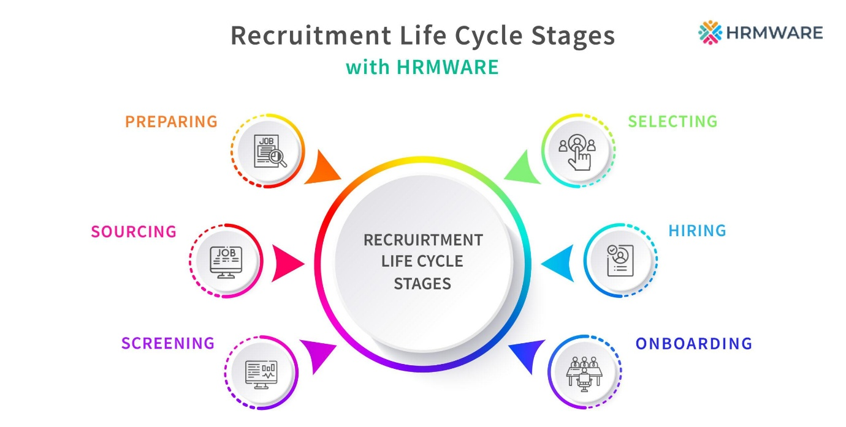
Figure 1.1.1 Recruitment Life Cycle Stages

Therefore, recruitment plays a vital role in organizational success, especially in the IT sector where the demand for skilled professionals is constantly increasing. Effective recruitment strategies combined with modern technologies can help organizations attract and retain talented employees while improving overall business performance.

According to a 2023 report by Gartner, over 60% of large enterprises had deployed some form of AI-assisted recruitment technology, with adoption rates in the IT sector exceeding 75%. The global AI in recruitment market is projected to grow from USD 590.5 million in 2022 to USD 1.1 billion by 2027, reflecting a compound annual growth rate (CAGR) of 6.7%. This growth trajectory underscores the strategic importance of understanding how AI transforms IT recruitment practices.

1.2 Importance of IT Recruitment

IT recruitment plays a crucial role in the success and growth of modern organizations because the Information Technology sector heavily depends on skilled and talented professionals. In today’s digital era, almost every organization relies on technology for communication, operations, customer service, innovation, and data management.

As a result, recruiting qualified IT professionals has become essential for maintaining productivity, efficiency, and competitiveness in the market. The IT industry requires employees with specialized technical skills in areas such as software development, cybersecurity, cloud computing, artificial intelligence, networking, and data analytics. Since technology evolves continuously, organizations must recruit candidates who not only possess current technical expertise but are also capable of adapting to new technologies and continuous learning.

Skilled IT professionals contribute directly to software development, system maintenance, security management, and technological innovation, helping organizations achieve business objectives effectively.

IT recruitment is also important because the industry faces intense competition and significant talent shortages. Many organizations compete to attract and retain highly qualified professionals, particularly in advanced fields such as Artificial Intelligence, Machine Learning, Cloud Computing, and Cybersecurity. Effective recruitment strategies help organizations secure talented candidates before competitors do and build high-performing teams that support innovation and business growth.
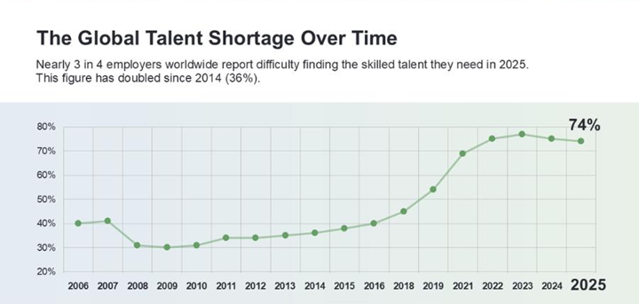
Figure 1.2.1 Global talent Shortage Over Time

In addition, proper recruitment reduces employee turnover and long-term hiring costs by ensuring better candidate-job matching and higher employee satisfaction. Hiring unsuitable candidates can lead to poor performance, increased operational expenses, project delays, and reduced productivity. Therefore, effective IT recruitment enables organizations to maintain workforce stability, improve operational performance, and remain competitive in the rapidly changing technological environment.

The Information Technology industry operates within a unique talent ecosystem that distinguishes it from most other sectors. Several structural characteristics make IT recruitment particularly complex and challenging for traditional HR approaches.

First, the rapid obsolescence of technical skills in IT means that the competencies required for positions change frequently. Programming languages, frameworks, cloud platforms, and cybersecurity methodologies evolve continuously, requiring recruiters to constantly update their understanding of what constitutes a qualified candidate. Second, the global nature of IT talent pools means that organizations compete across geographic boundaries for the same pool of highly specialized professionals, increasing competitive pressure on recruitment timelines.

Third, the volume challenge is acute in IT recruitment. Major IT organizations and tech companies routinely receive between 50,000 to 200,000 applications annually. Traditional manual screening of such volumes is simply not feasible from a cost and time perspective. Fourth, technical assessment presents a unique challenge: unlike many professions where credentials and experience serve as reliable proxies for competence, IT positions often require demonstration of specific technical skills that are difficult to assess through traditional interview methods alone.

The consequences of ineffective IT recruitment are significant. According to the Society for Human Resource Management (SHRM), the average cost of a bad hire is approximately 30% of the employee's first-year earnings. For senior IT positions, this can amount to hundreds of thousands of dollars. Furthermore, unfilled IT positions represent direct opportunity costs in terms of delayed projects, reduced productivity, and competitive disadvantage.

These structural challenges have created a compelling business case for technology-enabled solutions in IT recruitment. AI-powered tools offer the promise of faster, more accurate, and more consistent recruitment processes that can scale to match the volume demands of modern IT organizations while simultaneously improving the quality of hiring outcomes.

Table 1.2.1 Demand Level and Recruitment Difficulty Across IT Domains
IT Domain | Demand Level | Recruitment Difficulty
AI/ML | Very High | Very High
Cybersecurity | High | High
Cloud Computing | High | Medium
Data Analytics | Medium | Medium

1.3 Challenges in Traditional Recruitment

Traditional recruitment methods face several challenges, especially in the IT sector where organizations receive a large number of applications and require specialized technical skills. The major challenges are as follows:
- Time-Consuming Processes
Traditional recruitment involves manual resume screening, interview scheduling, and candidate evaluation, which consume significant time and delay the hiring process.
- Human Bias in Selection
Recruitment decisions are often influenced by personal opinions, assumptions, or unconscious bias, leading to unfair candidate selection.
- High Cost of Hiring
Organizations spend large amounts on advertisements, recruitment agencies, interview arrangements, and administrative activities, increasing overall hiring costs.
- Difficulty in Screening Large Volumes of Resumes
Recruiters face challenges in manually reviewing and shortlisting thousands of resumes, especially for IT positions requiring specialized skills.
- Lack of Data-Driven Decision Making
Traditional recruitment methods rely mostly on human judgment rather than analytical tools, reducing recruitment accuracy and efficiency.
- Long Hiring Cycles
Multiple rounds of manual screening and interviews increase the time required to fill job vacancies.
- Limited Candidate Reach
Traditional recruitment methods may fail to reach a wider pool of talented candidates compared to online and AI-based recruitment platforms.
- Inconsistent Candidate Evaluation
Different recruiters may evaluate candidates differently, leading to inconsistency in the hiring process.
- Increased Administrative Workload
HR teams spend excessive time handling repetitive tasks such as resume sorting, communication, and documentation.
- Poor Candidate Experience
Delayed responses and lengthy recruitment procedures may negatively affect candidate satisfaction and employer branding.
These challenges have encouraged organizations to adopt Artificial Intelligence and automated recruitment technologies to improve efficiency, reduce costs, and enhance the quality of hiring decisions.

1.4 Introduction to Artificial Intelligence in HR

Artificial Intelligence (AI) in Human Resource Management refers to the use of advanced technologies such as machine learning, data analytics, automation, and predictive algorithms to perform various HR functions more efficiently and accurately. AI helps organizations automate repetitive tasks, analyze large amounts of employee and recruitment data, and support better decision-making processes. In recent years, AI has become an important part of modern HR practices, especially in industries like Information Technology (IT), where organizations deal with large volumes of data and frequent recruitment activities.

Traditionally, HR departments handled tasks such as recruitment, employee training, payroll management, attendance tracking, and performance evaluation manually. These processes often required significant time, effort, and human involvement. However, with the introduction of AI technologies, organizations are now able to automate many of these activities, thereby improving efficiency, reducing operational costs, and enhancing employee experience.

One of the most common applications of AI in HR is recruitment and selection. AI-powered recruitment systems can automatically screen resumes, identify suitable candidates, schedule interviews, and even conduct preliminary assessments using chatbots and virtual assistants. Machine learning algorithms analyze candidate qualifications, skills, experience, and job requirements to match applicants with appropriate job roles. This helps recruiters save time and improve the quality of hiring decisions.

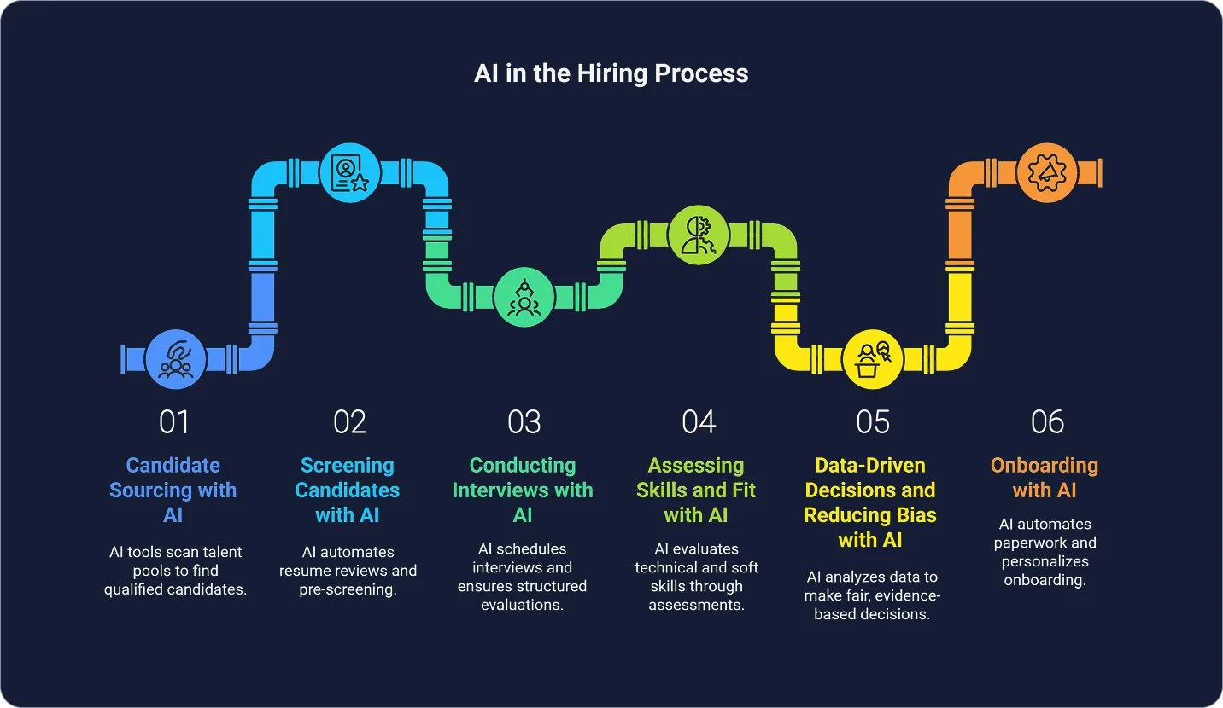
Figure 1.4.1 AI in Hiring Process

AI is also widely used in employee training and development. Organizations use AI-based learning platforms to provide personalized training programs based on employee performance, learning speed, and skill gaps. AI systems can recommend courses, monitor learning progress, and help employees improve their professional capabilities. This enhances workforce productivity and supports continuous learning within organizations.

Another important area where AI is applied is performance management. AI tools analyze employee performance data, attendance records, productivity levels, and feedback to evaluate employee performance objectively. Predictive analytics can help HR managers identify high-performing employees, detect potential issues, and make informed decisions regarding promotions, rewards, and employee retention strategies.

In addition, AI improves employee engagement and communication through chatbots and virtual HR assistants. Employees can quickly access information related to company policies, leave applications, payroll details, and benefits without waiting for HR personnel. This improves response time and overall employee satisfaction.

Despite its many advantages, AI in HR also presents certain challenges. Issues such as data privacy, algorithmic bias, lack of human interaction, and high implementation costs are major concerns for organizations. Therefore, AI should be used as a supportive tool rather than a complete replacement for human judgment in HR management.

Overall, Artificial Intelligence is transforming Human Resource Management by making HR processes faster, smarter, and more data-driven. Organizations that effectively integrate AI into HR functions can improve operational efficiency, enhance employee experience, and gain a competitive advantage in the modern business environment.

Table 1.4.1: Growth of AI in HR Technology Market (2018-2024)
Year | AI in HR Market Size (USD Million) | Growth Rate (YoY %) | IT Sector Adoption (%)
2018 | 180.5 | — | 35%
2019 | 245.3 | 35.9% | 42%
2020 | 310.7 | 26.7% | 51%
2021 | 420.1 | 35.2% | 61%
2022 | 590.5 | 40.5% | 71%
2023 | 720.3 | 22.0% | 75%
2024 | 850.0 | 18.0% | 80%

1.5 Need for AI in Recruitment

Artificial Intelligence (AI) is increasingly needed in recruitment processes to improve overall hiring efficiency, accuracy, and decision-making. The major reasons for adopting AI in recruitment are as follows:
- Improve Efficiency
AI automates repetitive recruitment tasks such as resume screening, candidate sourcing, interview scheduling, and communication. This helps HR professionals complete recruitment activities faster and more effectively.
- Reduce Hiring Time
AI-powered systems can quickly analyze thousands of resumes and shortlist suitable candidates within minutes, significantly reducing the overall recruitment cycle and time-to-fill positions.
- Enhance Accuracy in Candidate Selection
AI uses machine learning algorithms and data analysis to match candidate skills, qualifications, and experience with job requirements, improving the quality and accuracy of hiring decisions.
- Minimize Human Bias
AI-based recruitment systems help reduce unconscious human bias related to gender, age, appearance, or background by focusing primarily on candidate qualifications, skills, and performance data.
- Handle Large Volumes of Applications
Organizations often receive a large number of job applications, especially in the IT sector. AI helps efficiently manage and screen large volumes of resumes without manual effort.
- Improve Recruiter Productivity
By automating administrative and repetitive tasks, AI allows recruiters to focus more on strategic activities such as candidate engagement and final decision-making.
- Enhance Candidate Experience
AI chatbots and automated communication systems provide faster responses, interview updates, and better interaction with candidates, improving their overall recruitment experience.
- Support Data-Driven Decision Making
AI provides analytical insights and predictive data that help organizations make better and more informed recruitment decisions.
- Reduce Recruitment Costs
Automation reduces dependency on manual work, recruitment agencies, and lengthy hiring procedures, thereby lowering overall hiring costs.
- Increase Organizational Competitiveness
Faster and more effective recruitment helps organizations hire skilled employees quickly, enabling them to remain competitive in the rapidly changing business environment.
Therefore, Artificial Intelligence has become an essential tool in modern recruitment processes, particularly in the IT sector where speed, accuracy, and talent acquisition are highly important.

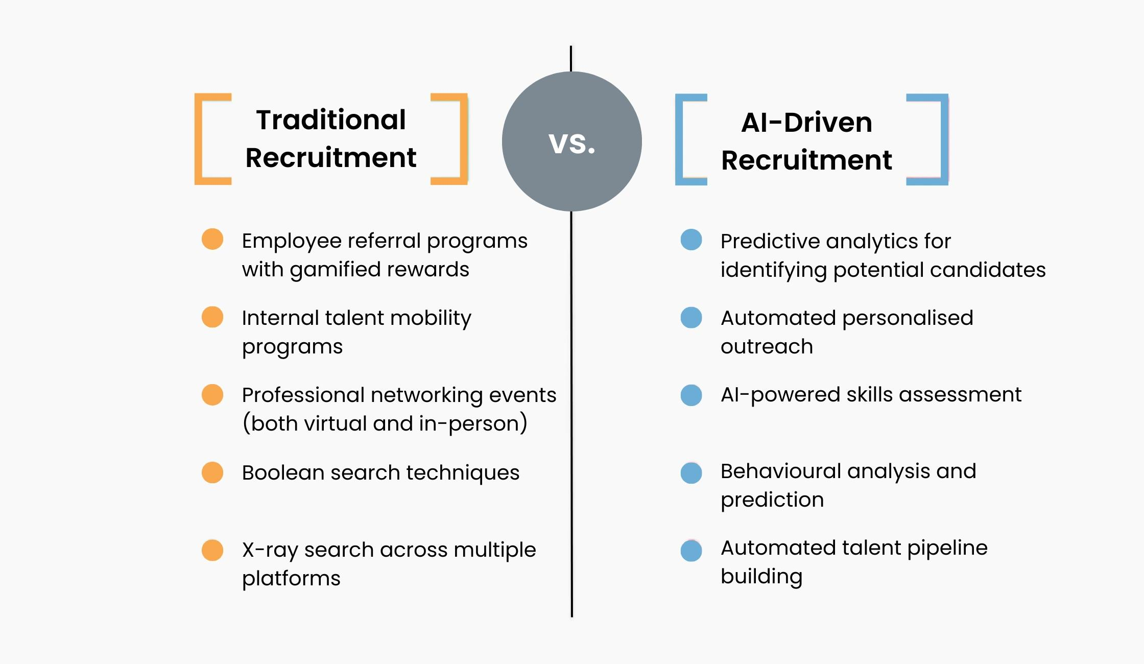
Figure 1.5.1: Traditional vs AI-Driven Recruitment

1.6 Justification for Selection of This Topic
The selection of this research topic — Integrating Artificial Intelligence in IT Recruitment Processes — is driven by both academic curiosity and practical relevance. As a student of Human Resources Management within the MBA program, the intersection of technology and people management presents one of the most pressing challenges and exciting opportunities of the current era.

First, the rapid proliferation of AI tools in HR has outpaced the academic literature evaluating their effectiveness. Most existing studies are either too broad in their industry focus or are limited to the perspectives of technology vendors rather than end-user organizations. There is a pressing need for empirical, organization-level research that examines the actual impact of AI integration on IT recruitment outcomes.

Second, this topic is directly relevant to current and future HR practitioners. As AI becomes increasingly embedded in recruitment workflows, HR professionals must develop a nuanced understanding of these technologies — their capabilities, limitations, and ethical implications. This research contributes to building that understanding.

Third, from a strategic perspective, organizations that successfully integrate AI into their talent acquisition processes gain a significant competitive advantage in attracting and retaining top IT talent. Understanding the factors that drive successful AI adoption in recruitment is therefore of considerable strategic value.

Finally, this topic aligns with Amity University Online's emphasis on applied, industry-relevant research that bridges the gap between academic theory and organizational practice. The insights generated from this study are expected to have direct practical implications for HR managers, IT leaders, and organizational decision-makers.

1.7 Scope of the Study
The present study focuses on the application of Artificial Intelligence (AI) in IT recruitment processes and its comparison with traditional recruitment methods. Recruitment is a critical function in the IT industry because organizations require highly skilled professionals to manage rapidly evolving technologies and business operations. Traditional recruitment methods, such as manual resume screening, newspaper advertisements, recruitment agencies, and face-to-face interviews, are often time-consuming, costly, and less efficient when handling large volumes of applications.

The study examines how AI-based recruitment technologies help organizations improve recruitment efficiency and effectiveness. AI tools such as Applicant Tracking Systems (ATS), resume screening software, predictive analytics, and recruitment chatbots are increasingly being used to automate various recruitment activities. These technologies assist recruiters in sourcing candidates, screening resumes, scheduling interviews, and identifying suitable applicants more accurately and quickly.

This study is primarily focused on the IT recruitment function within medium-to-large IT and IT-enabled services (ITeS) organizations. The research examines the adoption and impact of AI at various stages of the recruitment lifecycle, with particular emphasis on sourcing, screening, and selection. The geographic scope of the study includes IT hubs in India, with a focus on cities such as Bangalore, Hyderabad, Pune, Chennai, and the Delhi-NCR region.

The study covers the period from 2020 to 2024, encompassing the pre-COVID, COVID, and post-COVID phases of recruitment — a period during which AI adoption in HR accelerated significantly as organizations shifted to remote and hybrid work models.

The research also compares the advantages and limitations of AI recruitment systems with traditional hiring methods. While traditional methods rely heavily on human judgment and manual effort, AI-based systems provide faster processing, data-driven decision-making, and reduced human bias. However, the study also considers challenges associated with AI adoption, including implementation costs, ethical concerns, and lack of human interaction.

Overall, the study aims to understand the impact of Artificial Intelligence on modern IT recruitment practices and evaluate whether AI can improve hiring quality, reduce recruitment time, and enhance organizational productivity compared to traditional recruitment methods.

Table 1.7.1: Scope of the Study
Parameter | Scope
Industry | IT and ITES Organizations
Location | Bangalore, Hyderabad, Pune, Chennai, Delhi-NCR
Study Period | 2020–2024
Recruitment Stages | Sourcing, Screening, Selection
Technologies Studied | ATS, Resume Screening Software, Predictive Analytics, Chatbots
Comparison | AI Recruitment vs Traditional Recruitment

1.8 Objectives of the Study
- To understand traditional recruitment processes used in the IT sector.
- To analyze AI-based recruitment systems and their applications in hiring.
- To compare the efficiency and effectiveness of traditional recruitment methods with AI-driven recruitment systems.
- To identify the benefits of using Artificial Intelligence in recruitment processes.
- To examine the challenges and limitations associated with AI implementation in recruitment.
- To evaluate the impact of AI on recruitment speed, accuracy, and productivity.
- To study how AI helps reduce human bias in candidate selection.
- To provide recommendations for effective use of AI in IT recruitment practices.

1.9 Significance of the Study

This study is important because it helps organizations understand how Artificial Intelligence can improve recruitment processes, especially in the Information Technology (IT) sector where hiring skilled professionals is highly competitive and time-sensitive. Traditional recruitment methods often involve lengthy procedures, manual resume screening, high recruitment costs, and human bias, which can reduce the efficiency and effectiveness of hiring decisions. By examining AI-based recruitment systems, the study provides insights into how modern technologies can simplify and automate recruitment activities.

The findings of this research are expected to make several significant contributions. For practitioners, the study provides actionable insights on the most effective AI tools and strategies for IT recruitment, along with a roadmap for implementation. For academics, the study adds to the growing body of literature on AI in human resource management, offering empirical data and analysis from the Indian IT context. For policymakers, the research highlights considerations around data privacy, algorithmic bias, and the ethical deployment of AI in hiring decisions.

Furthermore, by identifying the key performance indicators (KPIs) most significantly impacted by AI adoption — specifically time-to-fill, cost-per-hire, and quality of hire — the study provides a framework that organizations can use to measure and evaluate the ROI of their AI recruitment investments.

The study also supports organizations in making better Human Resource (HR) decisions by highlighting the benefits of AI-driven recruitment tools such as Applicant Tracking Systems (ATS), machine learning algorithms, predictive analytics, and recruitment chatbots. These technologies help HR professionals reduce hiring time, improve candidate matching accuracy, enhance recruiter productivity, and manage large volumes of applications more effectively.
In addition, the research helps HR managers and organizations understand the challenges associated with AI implementation, including ethical concerns, implementation costs, and dependence on technology. The findings of the study can assist organizations in developing effective HR strategies that combine Artificial Intelligence with human judgment to achieve better recruitment outcomes.

Furthermore, the study contributes to academic knowledge by providing a better understanding of the role of AI in modern recruitment practices. It may also serve as a useful reference for researchers, students, HR professionals, and organizations interested in adopting AI technologies in recruitment and talent management processes.

Table 1.9.1: Significance of AI-Based Recruitment for Key Stakeholders
Stakeholder | Significance
HR Professionals | Improved recruitment efficiency and productivity
Organizations | Reduced hiring costs and faster recruitment
Candidates | Better candidate experience and communication
Researchers | Additional insights into AI in HRM
Policymakers | Understanding ethical and regulatory concerns

CHAPTER 2: REVIEW OF LITERATURE

2.1 Introduction to AI in Human Resource Management
The application of artificial intelligence (AI) in Human Resource Management (HRM) has been the subject of growing academic inquiry over the past decade, as organizations increasingly adopt data-driven approaches to manage workforce-related decisions. Early research in this area has focused on identifying the functional domains of HR where AI creates the most value, as well as evaluating its impact on efficiency, accuracy, and strategic decision-making.

Foundational work by Huang et al. (2019) established a comprehensive conceptual framework for AI in HRM. Their study categorized AI applications across six core HR functions: staffing, training and development, performance management, compensation, employee relations, and HR planning. Among these, staffing and recruitment were identified as the most suitable areas for AI integration. This is primarily due to the high volume of applicant data processed in recruitment cycles and the structured nature of decision-making in candidate screening and selection.

The authors further argued that AI systems can significantly reduce human bias in early-stage screening while improving speed and consistency in hiring decisions. However, they also emphasized that the effectiveness of AI depends heavily on the quality of training data and the transparency of algorithms used.

Building on this foundation, Raghavan et al. (2020) examined the rapid emergence and adoption of algorithmic hiring tools in corporate recruitment practices. Their study highlighted the increasing use of AI-powered Applicant Tracking Systems (ATS), automated resume screening tools, video interview platforms with AI-based behavioural and facial analysis, and chatbot systems for candidate engagement. According to their findings, by 2020, more than 70% of Fortune 500 companies had implemented at least one form of AI-assisted recruitment technology, indicating a significant shift toward automation in hiring processes.

The authors also noted that these technologies are not only improving efficiency but are also reshaping candidate experience by providing faster responses and continuous engagement throughout the recruitment lifecycle. However, concerns were raised regarding algorithmic transparency, fairness, and potential bias embedded in automated decision-making systems.

Human Resource Management
│
┌─────────┼─────────┐
Recruitment Training Performance
│ │ │
AI Tools AI Learning AI Analytics

AI Integration Across HR Functions

In a broader strategic context, Tambe et al. (2019) argued that HR is currently undergoing a critical inflection point driven by the convergence of big data analytics and machine learning technologies. According to their analysis, organizations that integrate AI-driven HR analytics into their decision-making processes are better positioned to enhance the quality of hiring decisions, improve employee retention, and optimize workforce planning.

They emphasized that AI enables HR professionals to move from intuition-based decisions to evidence-based strategies supported by predictive analytics. For example, machine learning models can identify patterns in employee performance and turnover, enabling HR managers to proactively address attrition risks and improve talent retention strategies.

Furthermore, Tambe et al. highlighted that AI adoption in HR is not merely a technological upgrade but a structural transformation of HRM practices. This transformation requires organizations to develop new capabilities, including data literacy among HR professionals, ethical governance frameworks, and cross-functional collaboration between HR and IT departments. Without these supporting structures, the potential benefits of AI may remain underutilized or even lead to unintended consequences such as discrimination or over-reliance on automated systems.

Overall, the literature suggests a clear consensus that AI has the potential to significantly enhance HRM functions, particularly in recruitment and talent management. While Huang et al. (2019) provide a foundational framework for understanding AI applications in HR, Raghavan et al. (2020) demonstrate the real-world adoption of these technologies in recruitment systems, and Tambe et al. (2019) position AI as a transformative force in strategic HR decision-making. However, despite these advancements, the literature also consistently highlights critical challenges related to ethics, transparency, bias, and the need for human oversight in AI-driven HR systems.

Table 2.1.1: AI Applications Across HR Functions
HR Function | AI Application
Recruitment & Selection | Resume Screening, ATS
Training & Development | Personalized Learning Systems
Performance Management | Predictive Analytics
Compensation | Salary Benchmarking Tools
Employee Relations | HR Chatbots
Workforce Planning | Forecasting Models

2.2 AI Applications in the Recruitment Lifecycle
Artificial intelligence has significantly transformed the recruitment lifecycle by automating and enhancing key stages such as resume screening, candidate matching, engagement, and interview assessment. The integration of AI technologies in recruitment processes has improved efficiency, reduced manual workload, and enabled more data-driven hiring decisions. Recent studies highlight four major areas where AI is most prominently applied: resume screening, natural language processing-based matching, chatbot-driven candidate engagement, and AI-based video interview assessment.

Resume screening is widely recognized as one of the earliest and most extensively studied applications of AI in recruitment. Van Esch et al. (2019) examined the effectiveness of machine learning algorithms in automating the resume screening process. Their findings indicate that AI-driven screening tools can reduce the time required to generate shortlists by up to 75% compared to traditional manual screening methods. This significant improvement in efficiency allows recruiters to focus more on strategic decision-making rather than administrative tasks. Furthermore, the study revealed that when machine learning models are properly trained on high-quality historical hiring data and regularly audited, they are capable of producing candidate shortlists with higher predictive validity for future job performance compared to those created by human recruiters. This suggests that AI systems can not only speed up the hiring process but also improve the overall quality of hiring outcomes.

However, the authors also emphasized that the reliability of such systems is highly dependent on data quality and careful model calibration.

In addition to resume screening, natural language processing (NLP) has emerged as a powerful tool for improving the accuracy of candidate-job matching. Luo et al. (2021) investigated how NLP techniques can be used to analyze both job descriptions and candidate resumes in a more contextual and semantic manner, moving beyond traditional keyword-based matching systems. Their research demonstrated that NLP-based algorithms are capable of identifying skill and experience alignment with accuracy rates exceeding 85%, significantly outperforming conventional filtering approaches.

This improvement is primarily due to the ability of NLP systems to understand context, interpret synonyms, and recognize transferable skills that may not be explicitly stated using identical terminology. As a result, organizations can identify a broader and more suitable pool of candidates, reducing the risk of overlooking qualified applicants due to rigid keyword dependencies. The study also highlights that such systems are particularly beneficial in large-scale recruitment environments where manual screening becomes impractical.

Another important application of AI in recruitment is the use of chatbot technology for candidate engagement. Nawaz and Gomes (2019) explored the role of AI-powered chatbots in the early stages of recruitment and found that these systems can effectively manage up to 90% of initial candidate queries.

These chatbots are capable of providing instant responses to frequently asked questions, guiding candidates through application procedures, and even scheduling interviews autonomously without human intervention. This automation not only improves operational efficiency but also enhances the candidate experience by ensuring continuous communication and reducing waiting times. Their findings further suggest a strong positive correlation between chatbot-assisted recruitment processes and improved employer brand perception.

Job Posting
↓
Candidate Sourcing
↓
AI Resume Screening
↓
NLP Candidate Matching
↓
Chatbot Interaction
↓
Video Interview Assessment
↓
Final Selection

AI-Enabled Recruitment Lifecycle

Candidates tend to view organizations more favourably when they experience responsive, transparent, and interactive communication during the hiring process. However, the study also notes that chatbot effectiveness depends on the quality of conversational design and the ability to escalate complex queries to human recruiters when necessary.

In addition to text-based applications, AI-driven video interview assessment has emerged as a rapidly evolving area in recruitment technology. Upadhyay and Khandelwal (2018) reviewed AI-enabled video interview platforms that analyze multiple aspects of candidate behaviour, including facial expressions, voice tone, speech patterns, word choice, and response structure. These systems generate automated evaluations of personality traits and competencies, which are then used to support hiring decisions.

The primary advantage highlighted in their review is the ability of AI systems to provide consistent and standardized assessments across all candidates, thereby reducing interviewer bias and subjective judgment. However, the authors also raised important concerns regarding the validity and ethical implications of such systems.

In particular, they questioned whether meaningful personality inferences can reliably be drawn from short video interactions, given the influence of cultural differences, nervousness, and contextual factors. They also emphasized the risk of over-reliance on automated assessments without adequate human oversight.

Overall, the literature indicates that AI applications across the recruitment lifecycle are significantly enhancing efficiency, scalability, and decision-making accuracy. Resume screening and NLP-based matching improve candidate selection speed and precision, chatbots enhance engagement and communication, and AI-based video interviews introduce standardized assessment mechanisms. However, despite these advantages, the studies collectively highlight the need for caution regarding issues such as algorithmic bias, transparency, data dependency, and ethical considerations. This suggests that while AI is a powerful enabler in recruitment, it should be implemented as a supportive tool rather than a complete replacement for human judgment.

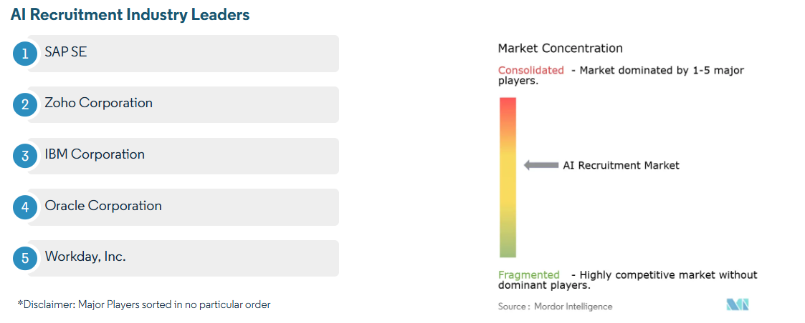
Figure 2.2.1: AI Recruitment Industry Leaders

2.3 Impact on Key Recruitment Metrics
Several empirical studies have attempted to quantify the impact of artificial intelligence on key recruitment performance metrics such as time-to-fill, cost-per-hire, quality-of-hire, and employee retention. With the increasing adoption of AI-based recruitment systems, organizations are not only focusing on process automation but also on measurable improvements in hiring outcomes. As a result, recent research has increasingly shifted toward evaluating AI in terms of tangible performance indicators rather than conceptual benefits alone.

A widely cited benchmark study conducted by IBM (2021) across 50 organizations provides strong evidence of the measurable benefits of AI in recruitment processes. The study found that organizations implementing AI-driven recruitment systems experienced an average reduction of 43% in time-to-fill positions. This indicates that AI significantly accelerates the hiring cycle by automating repetitive and time-consuming tasks such as resume screening, candidate shortlisting, and initial communication. In addition, the study reported a 35% reduction in cost-per-hire, suggesting that AI systems reduce dependency on manual HR effort, external recruitment agencies, and extended interview processes.

Furthermore, the study observed a 20% improvement in quality-of-hire, measured through 90-day performance review scores of newly hired employees. This improvement highlights that AI not only enhances efficiency but also contributes to better hiring decisions by improving candidate-job matching accuracy. These findings have been widely referenced in both academic literature and industry reports as benchmark indicators of AI’s potential to transform recruitment efficiency and effectiveness.

AI Implementation
↓ ↓ ↓ ↓
Time Cost Quality Retention
↓ ↓ ↑ ↑
43% 35% 20% 18%

Improvement in Recruitment Performance Metrics After AI Adoption

Extending these findings, Gonzalez and Tahir (2020) conducted a longitudinal study across six technology firms that implemented AI-assisted recruitment systems over a three-year period. Unlike cross-sectional studies, their research provides deeper insight into the long-term impact and adaptation process of AI integration in recruitment workflows.

Their findings revealed that time-to-fill reduced significantly from an average of 52 days to 31 days after full AI implementation. Similarly, cost-per-hire decreased from approximately USD 4,200 to USD 2,800, indicating substantial financial savings for organizations adopting AI-based systems. In addition to efficiency gains, the study also reported an 18% improvement in first-year employee retention rates, suggesting that AI-enabled recruitment processes may contribute to better candidate selection and organizational fit.

An important contribution of this study is the identification of an “adoption dip” phenomenon during the initial implementation phase of AI systems. The researchers observed that recruitment efficiency temporarily declined when AI tools were first introduced. This decline was attributed to factors such as employee learning curves, system calibration issues, integration challenges with existing HR systems, and resistance to change among recruitment staff.

However, after this adjustment period, performance metrics improved significantly, eventually surpassing pre-AI implementation levels. This finding highlights that while AI adoption offers long-term benefits, organizations must be prepared for short-term disruptions during the transition phase. It also emphasizes the importance of training, change management, and system optimization for successful AI integration in HR functions.

While global studies provide strong evidence of AI’s positive impact on recruitment outcomes, research specific to developing economies, particularly India, remains relatively limited but is steadily increasing. Krishnan and Patel (2022) conducted a study focusing on AI adoption in recruitment among 35 mid-sized IT companies in Bangalore, one of India’s major technology hubs.

Their findings revealed that organizations that had fully integrated AI into their recruitment workflows experienced a 40% improvement in candidate shortlisting speed. This improvement was primarily attributed to automated resume screening systems and AI-based skill matching tools, which significantly reduced the time required to filter large applicant pools.

Additionally, the study found a 28% reduction in the number of interview rounds required to finalize a hiring decision. This reduction indicates that AI tools helped improve the quality of initial candidate screening, allowing HR teams to focus only on the most relevant candidates earlier in the process.

As a result, organizations were able to streamline their recruitment pipelines and make faster hiring decisions without compromising candidate quality. The study further attributed these improvements to enhanced alignment between candidate skills and job requirements, achieved through AI-powered matching algorithms and data-driven screening criteria.

Table 2.3.1: Impact of AI on Recruitment Performance Metrics
Recruitment Metric | Before AI Implementation | After AI Implementation | Improvement
Time-to-Fill | 52 Days | 31 Days | 40%–43% Reduction
Cost-per-Hire | USD 4,200 | USD 2,800 | 35% Reduction
Quality-of-Hire | Baseline | Improved | 20% Increase
Employee Retention | Baseline | Improved | 18% Increase

Overall, the literature strongly suggests that AI has a significant and measurable impact on recruitment performance metrics. Across different contexts and industries, studies consistently report reductions in time-to-fill and cost-per-hire, along with improvements in quality-of-hire and employee retention. However, the findings also indicate that the benefits of AI are not immediate and require an adjustment period during implementation. Moreover, while global evidence is well-established, emerging research from the Indian IT sector confirms similar positive trends, suggesting that AI-driven recruitment improvements are applicable across diverse organizational and geographic contexts.

In conclusion, the empirical evidence demonstrates that AI is not only transforming recruitment processes at a functional level but also delivering quantifiable improvements in efficiency, cost-effectiveness, and hiring quality. However, successful outcomes depend heavily on proper implementation strategies, organizational readiness, and continuous system refinement.

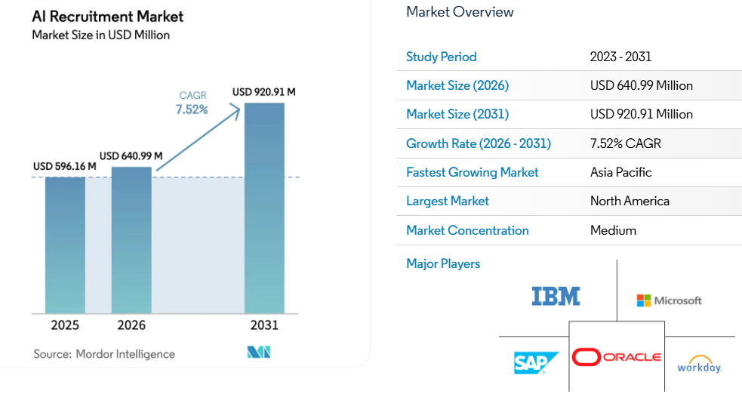
Figure 2.3.1: AI Recruitment Market Size and Share

2.4 Challenges and Ethical Considerations
While the efficiency gains from artificial intelligence (AI) in recruitment are well-documented across multiple studies, the academic literature also highlights several critical challenges and ethical concerns associated with its adoption. These concerns primarily revolve around algorithmic bias, fairness, transparency, and data privacy. As AI systems increasingly influence hiring decisions, researchers emphasize that the risks associated with their misuse or unregulated deployment can have long-term consequences for both organizations and candidates.

One of the most widely discussed issues in AI-driven recruitment is algorithmic bias. Dastin (2018) presented a landmark case study involving Amazon’s experimental AI recruitment system, which was found to systematically downgrade resumes associated with female candidates. The system had been trained on historical hiring data collected from a predominantly male-dominated technology sector, which unintentionally embedded historical gender bias into the algorithm. As a result, the AI model learned to Favor patterns associated with male candidates and penalize indicators linked to women, even when such indicators were irrelevant to job performance. This case became a pivotal moment in both academic and industry discussions, as it demonstrated how AI systems can replicate and even amplify existing societal inequalities if trained on biased datasets. It also highlighted the importance of critically evaluating training data before deploying machine learning models in high-stakes decision-making processes such as recruitment.
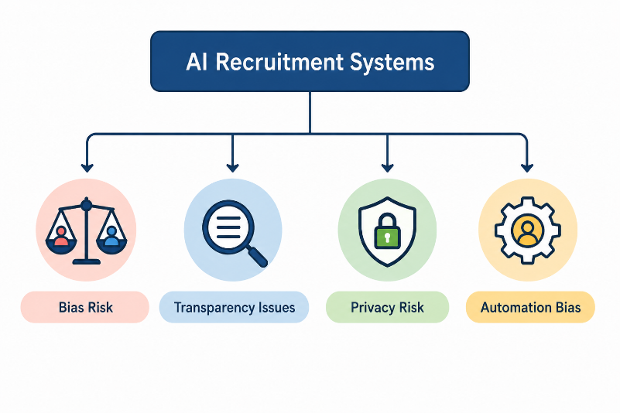
Figure 2.4.1: Ethical Risks in AI Recruitment

Building on this concern, Drage and Mackereth (2022) conducted a systematic review of algorithmic bias in AI hiring systems, providing a more comprehensive framework for understanding how bias emerges in recruitment technologies. Their study identified that bias can be introduced at multiple stages of the AI lifecycle. First, bias may exist in the training data itself, particularly when historical hiring decisions reflect long-standing discrimination or unequal opportunities. Second, bias may arise through the use of proxy variables, where seemingly neutral data points—such as educational institutions, employment gaps, or even language patterns—may indirectly correlate with protected characteristics such as gender, race, or socioeconomic status. Third, bias can also occur during the decision-making phase when human recruiters over-rely on AI-generated recommendations without critically evaluating their validity. This phenomenon, often referred to as automation bias, can result in the unquestioned acceptance of flawed or discriminatory outputs. The authors emphasize that addressing algorithmic bias requires a multi-layered approach, including dataset auditing, model transparency, and human oversight throughout the recruitment process.

In addition to fairness concerns, data privacy and regulatory compliance have emerged as significant challenges in the deployment of AI-based recruitment systems. Leicht-Deobald et al. (2019) examined the ethical and legal implications of using large-scale candidate data in AI-driven HR platforms. Their study highlights that modern recruitment technologies often collect and process vast amounts of personal information, including resumes, video interviews, social media activity, communication behaviour, and even psychometric or behavioural data. While such data enhances the predictive capability of AI systems, it also raises serious concerns regarding candidate privacy and consent. The authors identify a fundamental tension between the “data-hungry” nature of AI algorithms and the principles of data minimization and purpose limitation outlined in data protection frameworks such as the General Data Protection Regulation (GDPR).

Furthermore, the study points out that candidates are often unaware of the extent to which their data is collected, processed, and analyzed during AI-driven recruitment processes. This lack of transparency raises ethical questions regarding informed consent and the right to privacy. In many cases, candidates may not fully understand how algorithmic evaluations are conducted or how their personal information influences hiring decisions. The authors argue that organizations must ensure greater transparency by clearly communicating data usage policies and implementing strict governance mechanisms to safeguard candidate information.

Table 2.4.1: Major Ethical Challenges in AI-Based Recruitment
Ethical Issue | Description | Potential Impact
Algorithmic Bias | Bias in training data affects decisions | Unfair candidate selection
Lack of Transparency | AI decisions difficult to explain | Reduced trust in recruitment
Data Privacy | Collection of personal candidate data | Privacy violations
Automation Bias | Over-reliance on AI recommendations | Poor hiring decisions
Regulatory Compliance | Failure to follow data protection laws | Legal and financial risks

Overall, the literature indicates that while AI has the potential to significantly improve recruitment efficiency and decision-making, it also introduces complex ethical challenges that cannot be ignored. Algorithmic bias, as demonstrated in multiple studies, poses a serious risk of reinforcing existing inequalities in hiring practices. Similarly, concerns related to data privacy and regulatory compliance highlight the need for robust governance frameworks to ensure responsible AI adoption in HRM.

In conclusion, the successful implementation of AI in recruitment requires a balanced approach that integrates technological innovation with ethical responsibility. Organizations must not only focus on efficiency gains but also actively address issues of fairness, transparency, and data protection. Without such safeguards, the benefits of AI in recruitment may be undermined by unintended social and legal consequences.

2.5 Research Gaps
A comprehensive review of the existing literature on the application of artificial intelligence in Human Resource Management, particularly in recruitment processes, reveals several important gaps that remain insufficiently addressed. Although prior studies have extensively documented the benefits, challenges, and measurable impact of AI-driven recruitment systems, there is still a lack of focused, context-specific, and longitudinal research that captures the full complexity of AI adoption in real-world organizational environments. These gaps provide the foundation for the present study and highlight the need for further investigation.

The first major gap identified in the literature is the limited availability of empirical studies specifically focused on the Indian IT sector. While a significant portion of existing research originates from Western countries and large multinational corporations, the applicability of these findings in the Indian context remains underexplored. The Indian IT industry has unique characteristics, including a large and highly competitive talent pool, cost-sensitive recruitment practices, diverse educational backgrounds among candidates, and varying levels of technological maturity across organizations. Additionally, hiring practices in India are often influenced by regional labour market conditions, campus recruitment cycles, and high-volume entry-level hiring, which differ substantially from recruitment models in Western economies. As a result, the impact of AI in recruitment may not be uniform across contexts. Despite this, there is a noticeable shortage of region-specific empirical studies that examine how AI-driven recruitment systems perform within Indian IT organizations. This gap limits the generalizability of existing findings and creates a need for localized research that reflects the realities of the Indian labour market.

Existing Literature
│
▼
Focus on Global Studies
│
▼
Limited Indian IT Research
│
▼
Lack of Candidate Perspective
│
▼
Lack of Longitudinal Studies
│
▼
Need for Present Study

Conceptual Framework of Research Gaps Addressed by the Study

The second significant gap in the literature relates to the limited scope of perspectives considered in existing studies. Most research on AI in recruitment tends to focus either on the organizational viewpoint or on the technology provider’s perspective. Organizational-focused studies typically evaluate efficiency gains, cost reduction, and process optimization, while vendor-focused studies emphasize system capabilities and technological advancements. However, relatively few studies incorporate a dual-perspective approach that includes both recruiters and candidates. This is a critical limitation, as recruitment is inherently a two-sided process involving interaction between employers and job seekers. Recruiters may perceive AI systems as tools for improving efficiency and decision-making accuracy, whereas candidates may experience these systems in terms of fairness, transparency, communication quality, and overall recruitment experience. The absence of integrated studies that capture both perspectives results in an incomplete understanding of AI’s true impact on the recruitment ecosystem. Addressing this gap is essential for developing a more balanced and holistic view of AI adoption in HRM.

The third gap identified is the lack of longitudinal studies that examine the sustained impact of AI on recruitment performance over time. While many existing studies report short-term improvements in key metrics such as time-to-fill, cost-per-hire, and candidate matching accuracy, relatively few studies investigate whether these improvements are maintained in the long run. AI implementation in recruitment is not a one-time event but an evolving process that involves continuous model training, system updates, organizational adaptation, and user learning. Initial performance improvements may not necessarily reflect long-term outcomes, especially as systems scale and organizational complexity increases. Some studies suggest that organizations may experience an initial “adoption effect,” where performance temporarily fluctuates during the implementation phase before stabilizing. However, there is limited longitudinal evidence tracking recruitment performance beyond this initial phase. This creates uncertainty regarding the durability and long-term sustainability of AI-driven improvements in recruitment processes.

In addition to these primary gaps, there is also a broader methodological limitation observed in the existing literature. Many studies rely heavily on secondary data, case studies, or cross-sectional survey designs, which restrict the ability to establish causal relationships between AI adoption and recruitment outcomes. There is also limited use of mixed-method approaches that combine quantitative performance metrics with qualitative insights from stakeholders. This further restricts the depth of understanding regarding how AI systems influence recruitment practices in real organizational settings.

Overall, the literature clearly indicates that while AI in recruitment has been widely studied, there remains a lack of context-specific, multi-perspective, and longitudinal research, particularly within developing economies such as India. The identified gaps highlight the need for more comprehensive empirical studies that not only measure performance outcomes but also capture stakeholder experiences and long-term organizational impacts. This study aims to address these gaps by focusing on the Indian IT sector, incorporating multiple stakeholder perspectives, and analysing both immediate and sustained effects of AI adoption in recruitment processes.

In doing so, the study seeks to contribute to the existing body of knowledge by providing a more nuanced and contextually relevant understanding of how artificial intelligence is reshaping recruitment practices in contemporary organizations.

Table 2.5.1: Review of Literature on AI in Recruitment and HRM
Author | Year | Focus Area | Key Findings
Huang et al. | 2019 | AI in HRM | AI most useful in staffing
Van Esch et al. | 2019 | Resume screening | Reduced shortlisting time
Dastin | 2018 | AI bias | Gender discrimination risk

CHAPTER 3: RESEARCH OBJECTIVES AND METHODOLOGY

3.1 Research Objectives
The primary aim of this research is to investigate the impact of artificial intelligence on the IT recruitment process, with a specific focus on three key recruitment metrics: time-to-fill, cost-per-hire, and quality of hire. The specific objectives of this study are:
- To assess the current state of the recruitment process within IT organizations and identify key pain points and inefficiencies in the traditional recruitment workflow.
- To explore the range of AI tools and technologies currently being deployed in IT recruitment, including their specific applications at different stages of the recruitment lifecycle.
- To examine the potential benefits of integrating AI tools and technologies in the IT recruitment process, as perceived by HR professionals and recruitment managers.
- To evaluate the quantitative impact of AI implementation on key recruitment metrics, specifically time-to-fill, cost-per-hire, and quality of hire, through comparative pre- and post-implementation analysis.
- To identify the key challenges, barriers, and ethical considerations associated with AI adoption in IT recruitment, and develop evidence-based recommendations for addressing these challenges.

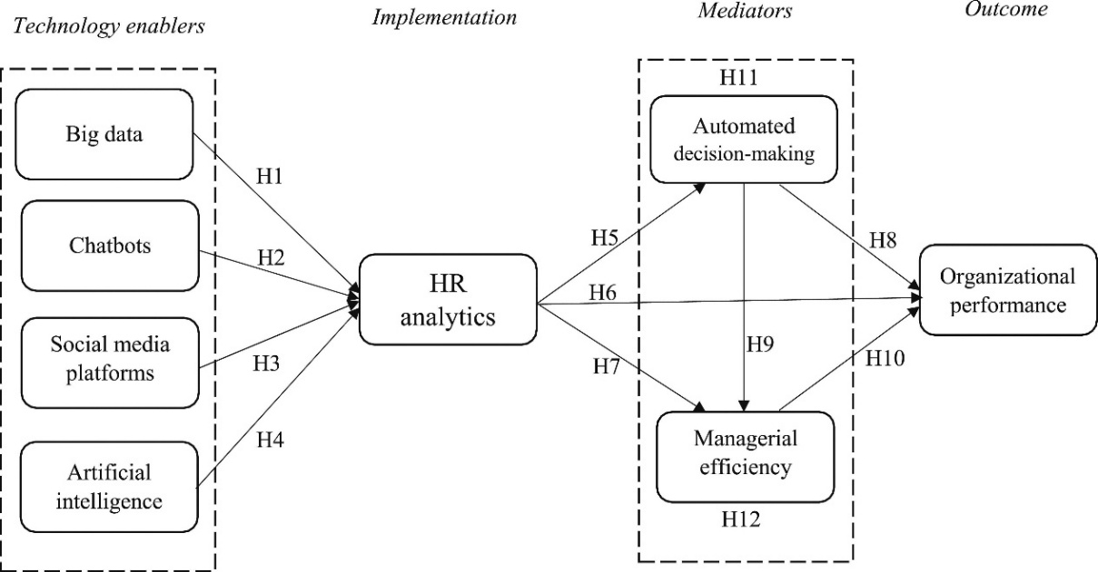

Figure 3.1.1: Conceptual Framework of HR Analytics

3.2 Research Problem
The central research problem addressed in this study is: To what extent does the integration of artificial intelligence in IT recruitment processes improve recruitment efficiency and effectiveness, as measured by time-to-fill, cost-per-hire, and quality of hire?

In recent years, artificial intelligence has increasingly been integrated into human resource management systems, particularly within recruitment functions in IT organizations. AI-based tools such as automated resume screening systems, natural language processing (NLP) algorithms, applicant tracking systems (ATS), chatbots, and predictive analytics platforms are being widely adopted to streamline recruitment workflows. These technologies are designed to reduce manual effort, accelerate candidate screening, improve matching accuracy, and enhance overall decision-making efficiency. However, despite rapid technological adoption, there remains limited empirical clarity regarding the actual extent to which these systems improve core recruitment performance metrics in real-world organizational contexts.

Recruitment is a critical function in IT organizations due to the continuous demand for highly skilled professionals and the competitive nature of the talent market. Traditional recruitment processes often involve multiple stages, including job posting, application screening, shortlisting, interviewing, and final selection. These processes are typically time-consuming, resource-intensive, and prone to human bias and inconsistency. As organizations attempt to optimize these processes, AI has emerged as a promising solution. However, while theoretical and industry-based claims strongly suggest that AI improves efficiency and effectiveness, there is still a need for systematic academic investigation to validate these claims using measurable recruitment outcomes.

The problem becomes more complex when considering that recruitment effectiveness is not solely defined by operational efficiency but also by the quality of hiring decisions. Key performance indicators such as time-to-fill measure how quickly positions are filled, cost-per-hire reflects the financial efficiency of recruitment operations, and quality of hire assesses the long-term value and performance of selected candidates. Although AI systems are expected to positively influence all three metrics, the extent and consistency of this impact remain unclear across different organizational settings, particularly in emerging economies such as India.

In addition to quantitative performance measurement, there is also a qualitative dimension to the research problem. The adoption of AI in recruitment significantly alters the roles and responsibilities of HR professionals and recruitment managers. While AI tools can support decision-making and reduce administrative burden, they may also introduce new challenges such as reduced human control, lack of transparency in algorithmic decisions, over-reliance on automated recommendations, and concerns regarding fairness and accountability. Furthermore, candidates’ experiences with AI-driven recruitment systems may vary depending on system design, communication quality, and perceived fairness. These human and organizational factors are critical to understanding the true impact of AI in recruitment but are often underexplored in purely quantitative studies.

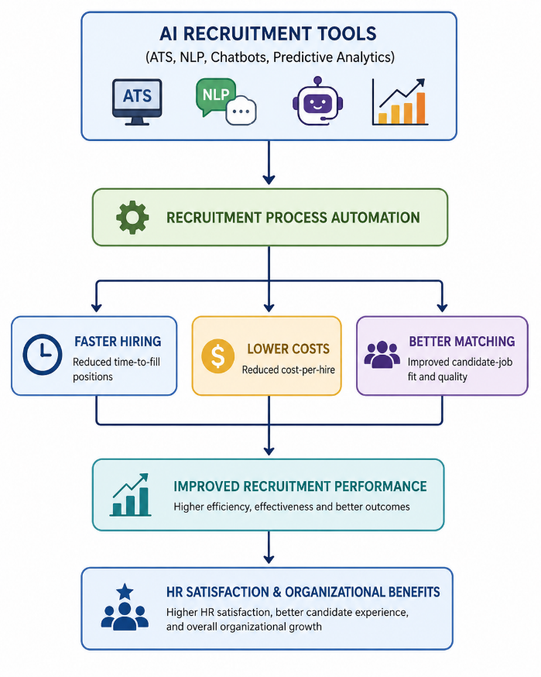
Figure 3.2.1 AI Tools and Recruitment Performance

Therefore, the research problem extends beyond simply measuring performance improvements. It also involves understanding how HR practitioners perceive and adapt to AI technologies, what challenges they face during implementation, and how these systems influence decision-making processes in recruitment. This dual focus highlights the complexity of AI adoption in HRM, where technological efficiency must be balanced with human judgment, ethical considerations, and organizational readiness.
Given this complexity, the study recognizes that a single methodological approach would be insufficient to fully address the research problem. The nature of the problem requires both numerical analysis of recruitment performance metrics and interpretative analysis of stakeholder experiences and perceptions. As a result, the research adopts a mixed-methods approach, combining quantitative evaluation of recruitment KPIs with qualitative insights from HR professionals and recruitment managers. This approach enables a more comprehensive understanding of both the measurable impact and the experiential dimensions of AI adoption in IT recruitment.

In summary, the core research problem lies in determining the extent to which artificial intelligence enhances recruitment efficiency and effectiveness in IT organizations, while also examining the associated human, organizational, and ethical implications. By addressing both quantitative outcomes and qualitative experiences, this study aims to provide a holistic and evidence-based assessment of AI’s role in transforming recruitment practices.

3.3 Research Design
This study employs a mixed-methods research design, integrating both quantitative and qualitative approaches to develop a comprehensive understanding of the impact of artificial intelligence (AI) on the IT recruitment process. The mixed-methods approach is considered most suitable for this research because it allows the study to simultaneously examine measurable changes in recruitment performance metrics and explore the lived experiences, perceptions, and interpretations of human resource (HR) professionals who interact with AI-driven recruitment systems.

The adoption of AI in recruitment is a multidimensional phenomenon that cannot be fully understood through a single methodological lens. On one hand, organizations seek to evaluate AI based on quantifiable outcomes such as time-to-fill, cost-per-hire, and quality of hire. On the other hand, the implementation of AI also influences human decision-making processes, workflow structures, and professional experiences within HR departments. Therefore, combining quantitative and qualitative methods enables a more holistic and nuanced analysis of both objective performance improvements and subjective stakeholder perspectives.

The quantitative component of this study is based on a descriptive-comparative research design. This design is used to examine and compare recruitment performance metrics before and after the implementation of AI tools in selected IT organizations. The primary objective of this component is to measure the extent to which AI adoption has influenced key recruitment indicators, including time-to-fill positions, cost-per-hire, and quality of hire. By comparing pre-implementation and post-implementation data, the study aims to identify statistically and practically significant changes in recruitment efficiency and effectiveness.

In this quantitative phase, recruitment data collected from participating organizations is analyzed to identify patterns and trends associated with AI adoption. The descriptive aspect of the design helps summarize the current state of recruitment performance, while the comparative aspect enables an evaluation of changes over time. This approach provides objective evidence regarding the impact of AI systems on recruitment outcomes and supports data-driven conclusions about their effectiveness.
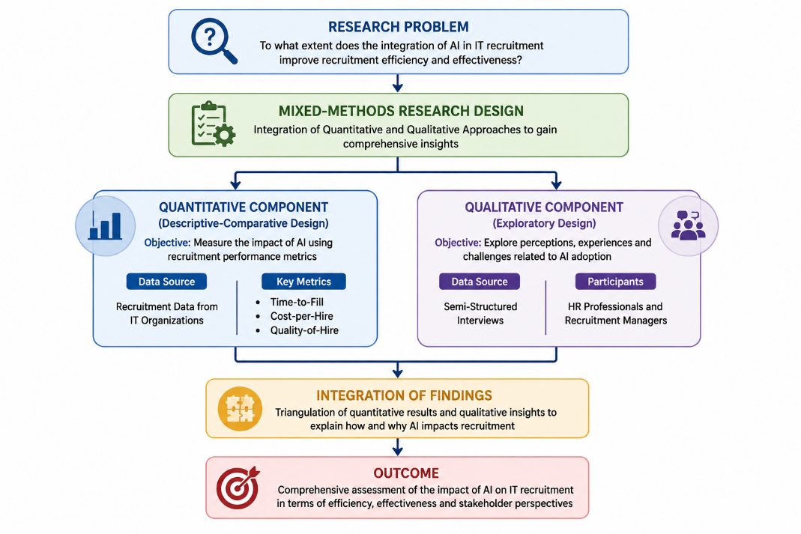
Figure 3.3.1: Mixed-Methods Research Design

The qualitative component of the study follows an exploratory research design, aimed at gaining in-depth insights into the experiences, perceptions, and attitudes of HR professionals and recruitment managers regarding AI adoption. This component is essential for understanding the contextual and human aspects of AI implementation, which cannot be captured through numerical data alone. Semi-structured interviews are conducted with selected HR practitioners who have direct experience using AI-based recruitment tools within their organizations.
The use of semi-structured interviews allows for flexibility in data collection, enabling participants to share detailed insights while ensuring that key thematic areas are covered consistently across interviews. These thematic areas include perceived benefits of AI in recruitment, challenges faced during implementation, changes in recruitment workflows, trust in AI-generated recommendations, and concerns related to fairness, transparency, and decision-making accountability. The exploratory nature of this design ensures that new themes and patterns can emerge from the data, providing a deeper understanding of how AI is experienced in real organizational settings.

The integration of both quantitative and qualitative components reflects the mixed-methods philosophy, which emphasizes complementarity between numerical measurement and contextual interpretation. While the quantitative data provides measurable evidence of AI’s impact on recruitment efficiency and effectiveness, the qualitative data enriches this understanding by explaining how and why these changes occur from the perspective of HR professionals.

Furthermore, this combined approach enhances the validity and reliability of the research findings through methodological triangulation. By comparing and cross-verifying results from both data sources, the study reduces the limitations associated with relying on a single method and provides a more robust and well-rounded analysis of the research problem.

In summary, the research design adopted in this study—comprising a descriptive-comparative quantitative approach and an exploratory qualitative approach within a mixed-methods framework—ensures a comprehensive evaluation of AI’s role in IT recruitment. It enables the study to not only measure performance outcomes but also understand the human and organizational dimensions of AI adoption, thereby addressing the research objectives in a balanced and systematic manner.

Table 3.3.1: Research Methodology Components and Description
Component | Description
Research Approach | Mixed Methods
Quantitative Method | Survey
Qualitative Method | Interviews
Research Type | Descriptive & Exploratory
Data Collection Tool | Questionnaire & Interviews
Data Analysis Tool | SPSS & NVivo

3.4 Type of Data Used
The present study adopts a comprehensive data collection approach by utilizing both primary data and secondary data sources. The combination of these two data types ensures a more robust, reliable, and well-rounded analysis of the research problem. While primary data provides firsthand, context-specific insights directly from industry professionals and organizations, secondary data offers a broader theoretical and empirical foundation derived from existing literature, industry reports, and published studies. Together, these data sources enable triangulation, which enhances the validity and credibility of the research findings.

The integration of both primary and secondary data is particularly important in the context of studying artificial intelligence (AI) in recruitment, as it is a rapidly evolving field that requires both real-world organizational insights and established academic understanding. Therefore, this dual approach ensures that the study captures both practical implementation realities and theoretical perspectives.

Primary Data Collection
Primary data refers to data that is collected directly by the researcher for the specific purpose of addressing the research objectives. In this study, primary data was collected from HR professionals, recruitment managers, and IT department heads working in various IT organizations. These participants were selected because they are directly involved in recruitment decision-making processes and have firsthand experience with AI-based recruitment tools and technologies.
The primary data was collected through three main methods: structured questionnaires, semi-structured interviews, and organizational recruitment data.

1. Structured Questionnaire Survey
A structured questionnaire was designed and administered to approximately 150 HR and recruitment professionals working across different IT organizations. The questionnaire served as the primary quantitative data collection tool and was used to gather standardized responses that could be statistically analyzed.

The questionnaire included both closed-ended and Likert-scale questions designed to measure key variables related to AI adoption in recruitment. These included perceptions of AI effectiveness, changes in recruitment efficiency, reduction in manual workload, improvement in candidate matching accuracy, and overall satisfaction with AI-based recruitment tools.
In addition, specific sections of the questionnaire focused on the three core recruitment metrics used in this study: time-to-fill, cost-per-hire, and quality of hire. Respondents were asked to compare these metrics before and after AI implementation within their organizations, allowing for a comparative analysis of recruitment performance.

The use of a structured questionnaire ensured consistency in responses and allowed for quantitative analysis using statistical tools. It also enabled the researcher to collect data from a relatively large sample size, thereby increasing the generalizability of the findings within the IT sector context.

2. Semi-Structured Interviews
In addition to the questionnaire survey, semi-structured interviews were conducted with 15 senior HR managers and recruitment leads. These participants were selected based on their extensive experience in recruitment and their direct involvement in AI implementation within their organizations.

The semi-structured interview format was chosen because it allows for flexibility in responses while maintaining focus on key research themes. Unlike structured questionnaires, semi-structured interviews enable participants to provide detailed explanations, examples, and insights based on their professional experiences.
The interviews explored several key areas, including:
- Perceived advantages and limitations of AI in recruitment processes
- Changes in recruitment workflows after AI adoption
- Level of trust in AI-generated recommendations
- Impact of AI on decision-making autonomy of HR professionals
- Challenges faced during implementation and integration of AI tools
- Ethical concerns such as fairness, transparency, and bias
These interviews provided rich qualitative data that helped in understanding the contextual and experiential aspects of AI adoption, which cannot be captured through quantitative methods alone. The insights gathered from HR leaders were particularly valuable in interpreting the practical implications of AI tools in real organizational environments.

3. Organizational Recruitment Data
To strengthen the quantitative analysis, anonymized recruitment data was collected from 10 participating IT companies. This data included pre- and post-AI implementation metrics related to recruitment performance.
The key data points collected included:
- Average time required to fill open positions (time-to-fill)
- Total cost incurred per hire (cost-per-hire)
- Quality-of-hire indicators based on performance evaluations or retention rates
- Number of candidates screened per position
- Interview-to-hire ratio
This organizational data allowed for a more objective comparison of recruitment performance before and after AI adoption. It also helped validate the responses obtained from HR professionals in the questionnaire survey. By analyzing actual organizational records rather than relying solely on perceptions, the study ensures greater accuracy and reliability in its quantitative findings.

Secondary Data Collection
Secondary data refers to information that has already been collected, published, and analyzed by other researchers, organizations, or institutions. In this study, secondary data was used to develop a strong theoretical foundation, support the literature review, and provide industry-level context for AI adoption in recruitment.
Secondary data was collected from a variety of credible and authoritative sources, including academic journals, industry reports, corporate case studies, and published research papers.
Table 3.4.1: Primary Data Sources
Data Source | Respondents/Records | Purpose
Structured Questionnaire | 150 HR & Recruitment Professionals | Measure AI impact on recruitment KPIs
Semi-Structured Interviews | 15 HR Managers & Recruitment Leads | Undersx`x`tand experiences and perceptions
Organizational Recruitment Data | 10 IT Companies | Compare recruitment metrics before and after AI adoption

1. Academic Journals and Research Publications
A significant portion of secondary data was obtained from peer-reviewed academic journals such as:
- Human Resource Management Journal
- Journal of Applied Psychology
- International Journal of Human Resource Management
- IEEE Access (for AI and machine learning applications in HR)
These journals provided theoretical frameworks, empirical findings, and methodological insights related to AI in HRM and recruitment analytics. They helped establish the academic foundation of the study and supported the identification of research gaps.

2. Industry Reports and Market Studies
Industry reports played a crucial role in understanding the current trends and real-world adoption of AI in recruitment. Key sources included:
- LinkedIn Talent Insights reports
- NASSCOM reports on IT workforce trends in India
- Gartner reports on HR technology adoption
- McKinsey Global Institute reports on AI and workforce transformation
These reports provided statistical data, market trends, and predictive insights regarding the adoption of AI technologies in recruitment processes globally and within India. They also helped contextualize the findings of the study within broader industry developments.

3. Corporate Case Studies and Whitepapers
Secondary data was also collected from corporate case studies and whitepapers published by AI recruitment tool providers and HR technology companies. These included documentation of real-world AI implementation in organizations, showcasing how different companies have integrated AI into their recruitment workflows.

These case studies provided practical insights into system functionalities, implementation strategies, challenges faced during deployment, and measurable outcomes achieved by organizations using AI-based recruitment solutions.

4. Published Research on AI and HRM
Additional secondary data was gathered from published research focusing on artificial intelligence in human resource management, recruitment analytics, organizational behavior, and workforce management. These studies provided comparative perspectives and helped in understanding the evolution of AI applications in HR over time.

Table 3.4.2: Secondary Data Sources
Source Type | Examples | Purpose
Academic Journals | HRM Journal, IEEE Access | Theoretical foundation
Industry Reports | LinkedIn, NASSCOM, Gartner, McKinsey | Industry trends and statistics
Corporate Case Studies | AI Recruitment Vendors | Practical implementation insights
Published Research | AI and HRM Studies | Comparative analysis and research gaps

3.5 Data Collection Methods
Data collection for the present study was carried out through two primary channels, namely an online survey and semi-structured interviews. These two methods were carefully selected to align with the mixed-methods research design adopted in this study. The combination of quantitative and qualitative data collection techniques ensured a comprehensive understanding of the impact of artificial intelligence (AI) on IT recruitment processes, capturing both measurable outcomes and experiential insights from HR professionals.

The data collection process was conducted in a systematic and structured manner to ensure reliability, validity, and consistency of the information gathered. Each method was designed to serve a specific purpose within the research framework, with the online survey focusing on quantitative measurement and the semi-structured interviews focusing on qualitative depth and contextual understanding.

Research Participants
(HR Professionals & Recruitment Managers)
│
▼
Data Collection
│
┌────┴────┐
│ │
▼ ▼
Online Survey Semi-Structured Interviews
(Google Forms) (Zoom Platform)
│ │
▼ ▼
Quantitative Data Qualitative Data
│ │
└────┬────┘
▼
Data Analysis
▼
Research Findings

Data Collection Process Adopted for the Study

Online Survey
The first and primary method of data collection was an online survey, which was designed using Google Forms. This digital platform was selected due to its ease of distribution, accessibility, cost-effectiveness, and ability to efficiently collect responses from a geographically diverse sample of respondents. Given that the target population included HR professionals working in IT organizations across India, an online format was considered the most practical and efficient approach.

The structured questionnaire was distributed via email and LinkedIn, two widely used professional communication platforms within the HR and IT industry. LinkedIn, in particular, played a significant role in reaching recruitment managers, HR executives, and talent acquisition specialists working in both mid-sized and large IT firms. Email distribution was used to reach professionals through organizational networks and personal contacts, ensuring broader coverage and improved response rates.

The survey consisted of 45 structured questions, carefully designed to align with the research objectives. The questionnaire was divided into multiple sections to ensure logical flow and clarity for respondents. These sections included:
- Demographic Information: This section collected background details such as job role, years of experience in HR or recruitment, organizational size, and industry segment. This information helped in understanding the profile of respondents and allowed for segmentation analysis.
- Current Recruitment Practices: This section focused on understanding traditional recruitment workflows, including resume screening methods, interview processes, candidate sourcing strategies, and challenges faced in manual recruitment systems.
- AI Tool Usage and Adoption: This section examined the extent to which AI-based tools such as applicant tracking systems (ATS), resume screening algorithms, chatbots, and video interview platforms were being used in their organizations. It also explored the level of integration of these tools into existing HR systems.
- Recruitment Metrics Comparison: A key section of the questionnaire focused on evaluating changes in recruitment performance indicators, specifically time-to-fill, cost-per-hire, and quality of hire. Respondents were asked to compare these metrics before and after AI implementation in their respective organizations.
- Perceptions of AI Effectiveness: This section captured the attitudes and perceptions of HR professionals regarding the effectiveness of AI in improving recruitment efficiency, reducing workload, enhancing candidate matching, and supporting decision-making processes.
The questionnaire included a mix of multiple-choice questions, Likert-scale items, and ranking questions to enable both quantitative measurement and comparative analysis. Likert-scale responses were particularly useful in measuring perceptions and attitudes toward AI adoption, allowing for statistical analysis of trends and patterns.

Prior to full distribution, the questionnaire was reviewed for clarity, relevance, and alignment with research objectives. A pilot test was conducted with a small group of HR professionals to ensure that the questions were understandable and free from ambiguity. Based on feedback, minor modifications were made to improve question clarity and structure.

A total of responses were collected from HR professionals working across various IT organizations in India. The use of an online survey ensured that data could be collected efficiently within a limited time frame while maintaining consistency in response format.

Semi-Structured Interviews
The second method of data collection involved semi-structured interviews, which were conducted to gather in-depth qualitative insights from experienced HR practitioners. These interviews were carried out with 15 senior HR professionals and recruitment practitioners who had direct experience in implementing or working with AI-based recruitment systems within their organizations.

The interviews were conducted virtually using the Zoom platform, which allowed for convenient scheduling and participation across different geographic locations. Each interview lasted between 45 to 60 minutes, providing sufficient time for detailed discussion of key themes while allowing flexibility for participants to elaborate on their experiences.

The semi-structured format was chosen because it provides a balance between guided questioning and open-ended discussion. While a predefined interview guide ensured that all relevant topics were covered consistently across participants, the flexible structure allowed interviewees to share additional insights, real-world examples, and contextual experiences that were not strictly limited by predefined questions.

Before each interview, participants were informed about the purpose of the study and assured of confidentiality and anonymity. Consent was obtained for recording the interviews to ensure accurate data capture and facilitate later transcription and analysis.
The interviews focused on several key areas, including:
- Experiences with AI-based recruitment tools in their organizations
- Perceived benefits and limitations of AI in recruitment processes
- Changes in recruitment workflows and HR roles after AI adoption
- Trust and reliance on AI-generated recommendations in hiring decisions
- Challenges faced during implementation and integration of AI systems
- Ethical concerns such as fairness, transparency, and algorithmic bias
- Impact of AI on decision-making speed and hiring quality

All interviews were audio-recorded (with consent) and later transcribed verbatim to ensure accuracy in qualitative data analysis. The transcribed data was then systematically analyzed using thematic analysis techniques to identify recurring patterns, themes, and insights related to AI adoption in recruitment.

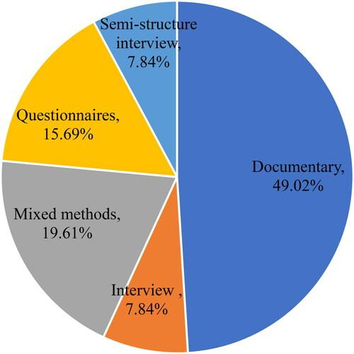
Figure 3.5.1: Distribution of Data Collection Methods

3.6 Data Collection Instruments
The primary data collection instrument used in this study was a structured questionnaire, specifically designed to gather quantitative data from HR professionals, recruitment managers, and IT practitioners involved in recruitment processes. The questionnaire was carefully developed to align with the research objectives and ensure comprehensive coverage of all relevant dimensions of artificial intelligence (AI) adoption in IT recruitment. It was divided into six distinct sections, each focusing on a specific aspect of the recruitment lifecycle, AI integration, performance outcomes, and ethical considerations.

The structured nature of the questionnaire ensured consistency in responses, making it suitable for statistical analysis and comparative evaluation of recruitment metrics before and after AI implementation. The instrument incorporated a combination of Likert-scale items, multiple-choice questions, and numerical input fields, allowing for both perception-based and data-driven responses.
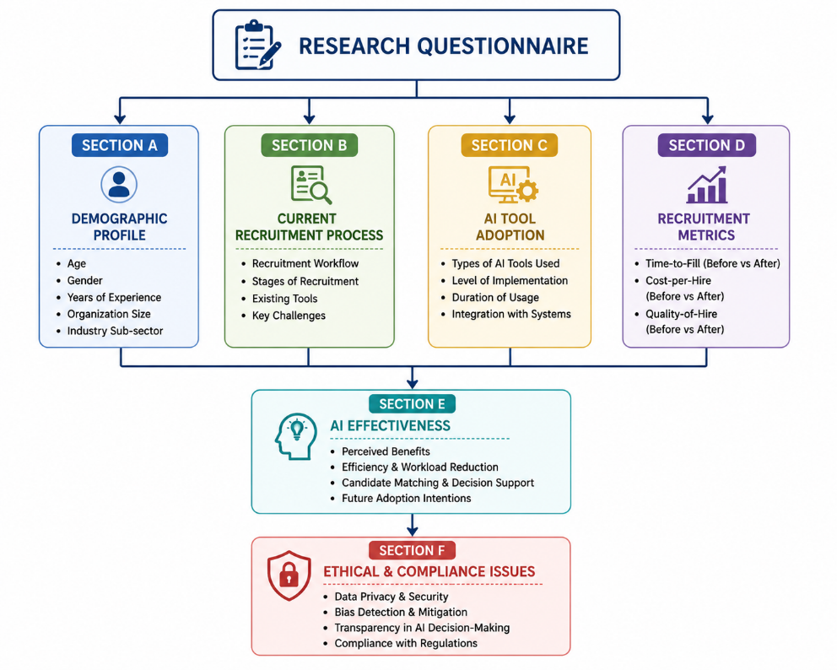
Table 3.6.1 Questionnaire Design Framework

Section A: Demographic Profile
The first section of the questionnaire focused on collecting demographic and professional background information of the respondents. This section included variables such as age, gender, years of experience in human resource management or recruitment, organizational size, and industry sub-sector within the IT domain.

The purpose of this section was to understand the profile of respondents and ensure that the sample represented a diverse range of HR professionals working in different organizational contexts. Information such as years of experience and organizational size also helped in analysing whether perceptions of AI adoption varied across different levels of professional expertise and organizational maturity. This demographic segmentation provided a foundation for interpreting the results in a more meaningful and contextualized manner.

Section B: Current IT Recruitment Process
The second section of the questionnaire focused on understanding the existing recruitment practices within IT organizations before or without AI integration. This section included questions related to the various stages of the recruitment process, such as job requisition, candidate sourcing, resume screening, shortlisting, interviewing, and final selection.

Respondents were also asked to provide information regarding average recruitment timelines, key challenges faced in traditional recruitment workflows, and the types of tools currently used in their organizations (such as manual tracking systems or basic applicant tracking systems without AI capabilities).

The objective of this section was to establish a baseline understanding of traditional recruitment practices and identify inefficiencies or bottlenecks that AI technologies aim to address. This helped in comparing traditional methods with AI-enabled recruitment processes in later sections of the study.

Section C: AI Tool Adoption
The third section focused specifically on the adoption and implementation of AI-based recruitment tools within organizations. This included questions related to the types of AI tools being used, such as machine learning-based applicant tracking systems, natural language processing (NLP) tools for resume parsing, AI chatbots for candidate engagement, and video interview analysis platforms.

Respondents were also asked to indicate the stage of implementation of AI tools in their organization (pilot stage, partial implementation, or full integration), as well as the duration of usage of these technologies.

This section aimed to capture the level of technological maturity in recruitment processes and understand how extensively AI tools have been integrated into HR functions. It also helped in categorizing organizations based on their level of AI adoption for comparative analysis.

Section D: Impact on Recruitment Metrics
The fourth section of the questionnaire was designed to collect quantitative data on key recruitment performance indicators, specifically time-to-fill, cost-per-hire, and quality of hire. Respondents were asked to provide comparative data for these metrics before and after AI adoption within their organizations.

Time-to-fill measured the average number of days required to fill a position, cost-per-hire captured the total recruitment expenditure per hire, and quality of hire was assessed based on internal performance ratings, retention rates, or managerial evaluations of new employees.
This section formed the core of the quantitative analysis in the study, as it provided measurable evidence of the impact of AI on recruitment efficiency and effectiveness. By comparing pre- and post-AI implementation data, the study aimed to identify statistically significant improvements or changes in recruitment outcomes.

Section E: Perceptions of AI Effectiveness
The fifth section focused on perceptual and attitudinal responses from HR professionals regarding the effectiveness of AI in recruitment. This section used a 5-point Likert scale ranging from strongly disagree to strongly agree.

Statements in this section assessed perceived benefits such as improved efficiency, reduced workload, enhanced candidate matching, faster decision-making, and improved hiring quality. It also included items related to perceived challenges, such as system complexity, lack of transparency, over-reliance on automation, and concerns about fairness.

Additionally, this section included questions related to future intentions, such as willingness to further adopt AI tools, expand AI usage in recruitment, and recommend AI systems within their organizations.
The purpose of this section was to capture subjective experiences and attitudes, which are essential for understanding how AI is perceived and accepted by HR professionals in real-world settings.

Section F: Ethical and Compliance Considerations
The final section addressed ethical concerns and compliance practices related to AI adoption in recruitment. This included questions on data privacy practices, candidate consent mechanisms, bias detection and mitigation strategies, and adherence to relevant data protection regulations.

Respondents were asked to indicate whether their organizations had formal policies for handling candidate data, how transparency in AI decision-making was ensured, and what measures were in place to minimize algorithmic bias.
This section was particularly important in understanding the ethical implications of AI deployment in HRM and ensuring that technological advancements align with legal and ethical standards.

Table 3.6.1: Structure of the Research Questionnaire
Section | Focus Area | Key Variables Measured
A | Demographic Profile | Age, Gender, Experience, Organization Size
B | Current IT Recruitment Process | Recruitment Workflow, Challenges, Existing Tools
C | AI Tool Adoption | ATS, NLP, Chatbots, Video Interview Platforms
D | Impact on Recruitment Metrics | Time-to-Fill, Cost-per-Hire, Quality-of-Hire
E | Perceptions of AI Effectiveness | Efficiency, Workload Reduction, Decision Support
F | Ethical & Compliance Considerations | Privacy, Bias, Transparency, Regulatory Compliance

Validation and Reliability of the Instrument
To ensure the validity and reliability of the research instrument, the questionnaire underwent a rigorous validation process. Initially, the instrument was reviewed by two academic experts in Human Resource Management and research methodology, who evaluated the questionnaire for content relevance, clarity, and alignment with research objectives. Based on their feedback, minor modifications were made to improve question wording, structure, and logical flow.

Following expert validation, a pilot test was conducted with 15 HR professionals working in IT organizations. The purpose of the pilot study was to assess the clarity of questions, response consistency, and overall usability of the questionnaire. Feedback from the pilot test indicated that the instrument was clear, relevant, and easy to understand, with only minor adjustments required in terminology and question sequencing.

To assess the internal consistency of the Likert-scale items in Section E, Cronbach’s alpha reliability test was conducted. The results showed a Cronbach’s alpha value of 0.87, which indicates a high level of internal consistency and reliability of the scale. This confirms that the items used to measure perceptions of AI effectiveness were statistically reliable and suitable for further analysis.

3.7 Sample Size
The target population for this study consisted of Human Resource (HR) professionals, recruitment managers, talent acquisition specialists, and hiring executives working in Information Technology (IT) and Information Technology Enabled Services (ITeS) organizations across India. These professionals were selected because they are directly involved in recruitment activities and possess practical experience with both traditional and AI-enabled recruitment systems. Their insights were considered highly valuable for understanding the impact of artificial intelligence on recruitment efficiency, effectiveness, and decision-making processes within contemporary organizations.

Determining an appropriate sample size was an important step in ensuring the reliability and validity of the research findings. To achieve statistically meaningful results, the sample size was calculated using a confidence level of 95 percent and a margin of error of ±8 percent. Based on these parameters, the minimum recommended sample size was determined to be 150 respondents. This sample size was considered adequate to represent the target population and to provide sufficient data for quantitative analysis.

A non-probability purposive sampling technique was adopted for the study. This sampling method was chosen because the research required participants who possessed specific knowledge and experience related to recruitment practices and the use of AI-based recruitment tools. The purposive approach enabled the researcher to identify and select respondents who could provide relevant and informed perspectives on the research topic. Participants were approached through professional networking platforms such as LinkedIn, organizational contacts, HR communities, and email communication channels.

For the quantitative component of the study, a total of 187 questionnaires were distributed among HR professionals and recruitment practitioners working in various IT and ITeS organizations. Out of these, 156 completed questionnaires were received, resulting in a high response rate. After careful screening and validation, 148 questionnaires were found to be complete and suitable for analysis. Some responses were excluded due to incomplete information, missing data, or inconsistencies that could affect the accuracy of the results. The final response rate was calculated at 79.1 percent, which is considered satisfactory for academic research and indicates a strong level of participant engagement.

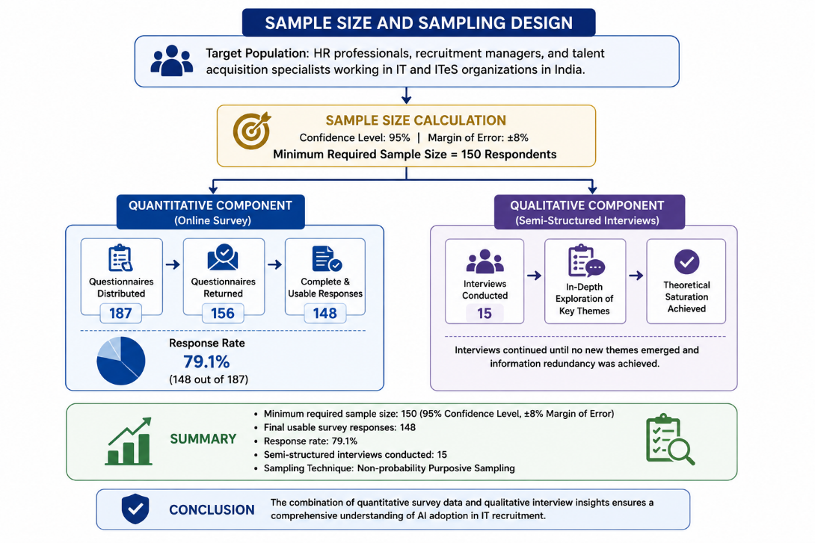
Figure 3.7.1: Sampling Design and Sample Size Framework

In addition to the quantitative survey, the study also incorporated a qualitative component to gain deeper insights into the experiences and perceptions of HR professionals regarding AI adoption in recruitment. For this purpose, semi-structured interviews were conducted with 15 senior HR managers, recruitment leads, and talent acquisition specialists who had direct experience with AI-driven recruitment systems. These participants were selected based on their professional expertise and involvement in implementing or managing AI-enabled recruitment technologies within their organizations.

The number of interview participants was determined using the principle of theoretical saturation. Theoretical saturation occurs when additional interviews no longer generate new themes, patterns, or insights relevant to the research objectives. During the data collection process, recurring themes began to emerge consistently across participants, indicating that sufficient qualitative data had been gathered. Therefore, conducting 15 interviews was considered appropriate for achieving depth of understanding while maintaining research efficiency.

Overall, the combination of 148 valid survey responses and 15 in-depth interviews provided a strong empirical foundation for the study. The selected sample enabled both quantitative measurement and qualitative exploration of AI adoption in recruitment, ensuring a comprehensive and balanced analysis of the research problem.

Table 3.7.1: Distribution of Respondents by Professional Category
Category | Number of Respondents
HR Managers | 45
Recruitment Specialists | 58
Talent Acquisition Leads | 30
IT Department Heads | 15

3.8 Sampling Technique
The present study adopts a combination of purposive sampling, snowball sampling, and non-probability convenience sampling techniques to select appropriate respondents and organizations for data collection. The use of multiple sampling techniques was necessary due to the specialized nature of the research topic, which focuses on the application of artificial intelligence (AI) in IT recruitment processes. Since the target population consists of HR professionals with specific expertise in recruitment and AI tool usage, probability sampling methods were not considered feasible. Instead, non-probability sampling techniques were employed to ensure that relevant and information-rich participants were included in the study.

Target Population
(HR Professionals & IT Organizations)
│
▼
Sampling Techniques
│
┌─────┼─────┐
│ │ │
▼ ▼ ▼
Purposive Snowball Convenience
Sampling Sampling Sampling
│ │ │
▼ ▼ ▼
HR Experts Referred HR IT Companies
& Managers Professionals Providing Data
│ │ │
└─────┼────┘
▼
Final Sample
(148 Survey Responses +
15 Interviews)

Sampling Framework of the Study

Purposive Sampling
The primary sampling technique used in this study was purposive sampling, also known as judgmental sampling. This method involves the deliberate selection of participants based on specific characteristics and the researcher’s judgment regarding their relevance to the study objectives. In this case, HR professionals, recruitment managers, and IT department heads who had direct experience in recruitment processes and exposure to AI-based recruitment tools were identified as the target population.

Purposive sampling was particularly appropriate for this study because not all HR professionals have experience with AI-driven recruitment systems. Therefore, it was essential to ensure that selected participants possessed relevant knowledge and practical experience in implementing or using AI tools such as applicant tracking systems (ATS), machine learning-based screening tools, chatbot systems, and AI-powered interview platforms.

Participants were selected from IT organizations of varying sizes, including mid-sized companies and large enterprises, to ensure diversity in organizational practices and levels of AI adoption. This approach helped in capturing a broad range of perspectives regarding the implementation and impact of AI in recruitment processes. The purposive sampling technique ensured that the data collected was both relevant and meaningful, thereby enhancing the validity of the study findings.

Snowball Sampling
In addition to purposive sampling, the study also employed snowball sampling to expand the respondent base. Snowball sampling is a non-probability technique in which existing participants are asked to refer other potential respondents who meet the required eligibility criteria. This method is particularly useful in studies where the target population is relatively specialized or difficult to access.

After initial participants were identified through purposive sampling, they were requested to recommend colleagues or other HR professionals who had experience with AI-based recruitment tools. These referrals helped in expanding the sample size and reaching a wider network of qualified respondents across different IT organizations.
Snowball sampling proved to be highly effective in this study because HR professionals working with AI recruitment systems are often part of specialized professional networks. Through referrals, the researcher was able to access additional participants who may not have been reachable through direct contact methods such as email or LinkedIn outreach.

This technique also helped in improving the diversity of the sample, as participants were drawn from different organizational contexts, including multinational IT companies, mid-sized firms, and emerging technology startups. However, it is important to acknowledge that snowball sampling may introduce certain limitations, such as potential sampling bias, since participants are likely to refer individuals within their own professional networks. Despite this limitation, the method was deemed appropriate for achieving the exploratory and context-specific objectives of the study.

Non-Probability Convenience Sampling for Organizational Data
For the organizational data component of the study, a non-probability convenience sampling approach was used. This method involves selecting organizations based on their accessibility, willingness to participate, and availability of relevant data. In this study, IT organizations were included based on their confirmed usage of AI-based recruitment tools and their willingness to share anonymized recruitment data.

A total of 10 IT organizations participated in the study by providing access to pre- and post-AI implementation recruitment metrics. These organizations were selected based on convenience and accessibility, as well as their readiness to contribute to academic research. All participating organizations had been using AI-driven recruitment tools for at least one year, ensuring that sufficient post-implementation data was available for comparative analysis.

The use of convenience sampling in this context was practical due to the sensitive nature of organizational recruitment data. Many companies are reluctant to share internal HR metrics such as cost-per-hire, time-to-fill, and employee performance data. Therefore, only those organizations that were willing to cooperate and ensure data confidentiality were included in the sample.

Despite its limitations in terms of generalizability, convenience sampling was suitable for this study because the primary objective was not to generalize findings to all IT organizations globally, but rather to analyze real-world impacts of AI adoption within a relevant and accessible sample.

Rationale for Combined Sampling Approach
The combination of purposive, snowball, and convenience sampling techniques was strategically chosen to align with the mixed-methods research design of the study. Each sampling method served a distinct purpose in ensuring that the research objectives were effectively met.

Purposive sampling ensured that only relevant and experienced HR professionals were included in the study. Snowball sampling helped in expanding the respondent pool through professional networks, thereby increasing sample diversity and reach. Convenience sampling allowed for the inclusion of real organizational data, which is essential for conducting quantitative analysis of recruitment performance metrics.

Together, these sampling techniques ensured that the study captured both depth and diversity of data, which is critical for analysing the multifaceted impact of AI in IT recruitment. While probability sampling would have been ideal for generalization, it was not feasible due to the specialized nature of the population and limitations in data accessibility.

Limitations of Sampling Methods
It is important to acknowledge that non-probability sampling techniques come with certain limitations. These include the possibility of sampling bias, limited generalizability, and dependence on participant availability. However, given the exploratory nature of the study and the focus on experienced professionals within a specific domain, these methods are appropriate and widely accepted in HRM and organizational research studies involving niche populations.

3.9 Data Analysis Tools
The present study employs a combination of quantitative and qualitative data analysis techniques in alignment with its mixed-methods research design. The use of both statistical and interpretive approaches ensures a comprehensive examination of the impact of artificial intelligence (AI) on IT recruitment processes. Quantitative data collected through structured questionnaires and organizational records was analyzed using statistical methods, while qualitative data obtained through semi-structured interviews was analyzed using thematic analysis. This dual approach allows the study to capture both measurable changes in recruitment performance and deeper contextual insights from HR professionals.

Quantitative Data Analysis
Quantitative data collected from the survey responses and organizational recruitment records was analyzed using IBM SPSS Statistics (Version 26). SPSS was chosen due to its robustness, reliability, and wide acceptance in social science and management research for performing statistical analysis. The quantitative analysis aimed to examine patterns, relationships, and differences in recruitment performance metrics before and after AI implementation.

Collected Data
│
┌─────┴─────┐
│ │
▼ ▼
Quantitative Data Qualitative Data
(Survey & Company Data) (Semi-Structured Interviews)
│ │
▼ ▼
IBM SPSS 26 NVivo 12
│ │
▼ ▼
Descriptive Statistics Thematic Analysis
Paired Sample t-Test │
Correlation Analysis │
Regression Analysis │
│ Themes
▼ │
└────────┬────────┘
▼
Integrated Findings
▼
Assessment of AI Impact on IT Recruitment

Data Analysis Framework

The following statistical techniques were employed:

1. Descriptive Statistics
Descriptive statistical analysis was conducted as the first step in the quantitative data analysis process. This included the calculation of mean, median, standard deviation, frequency distributions, and percentages.
The purpose of descriptive statistics was to summarize and present the basic features of the dataset in a structured manner. For example, demographic profiles of respondents such as age, gender, years of experience, and organizational size were analyzed using frequency distributions. Similarly, recruitment practices, AI adoption levels, and perceived effectiveness were summarized using mean and standard deviation values.
Descriptive analysis also helped in identifying general trends in recruitment practices across IT organizations, such as the extent of AI tool usage, average time-to-fill positions, and perceived improvements in recruitment efficiency.

2. Paired Samples t-Test
A paired samples t-test was used to compare recruitment performance metrics before and after the implementation of AI tools. This statistical test is appropriate for comparing two related groups or conditions, in this case, pre-AI and post-AI recruitment performance within the same organizations.
The key variables analyzed using this method included:
- Time-to-fill positions
- Cost-per-hire
- Quality of hire
The objective of this test was to determine whether the differences observed in recruitment metrics before and after AI adoption were statistically significant. By applying the paired t-test, the study was able to evaluate whether AI implementation led to measurable improvements in recruitment efficiency and effectiveness rather than changes occurring due to random variation.

3. Pearson Correlation Analysis
To examine the relationship between AI adoption and recruitment performance improvements, Pearson correlation analysis was conducted. This method was used to assess the strength and direction of the relationship between variables such as AI tool adoption intensity and changes in recruitment metrics.
For example, the study analyzed whether higher levels of AI integration (e.g., full automation of resume screening or chatbot usage) were associated with greater reductions in time-to-fill or cost-per-hire. The correlation coefficient helped in identifying whether these relationships were positive, negative, or negligible.
This analysis provided important insights into whether increased reliance on AI tools is directly associated with improved recruitment outcomes, thereby contributing to a deeper understanding of AI’s effectiveness in HRM processes.

4. Regression Analysis
Multiple regression analysis was conducted to identify predictors of successful AI adoption outcomes in recruitment. This technique allowed the study to examine the combined effect of multiple independent variables on dependent variables such as recruitment efficiency and quality of hire.
Independent variables included factors such as:
- Level of AI tool integration
- Organizational size
- HR team experience with AI systems
- Duration of AI usage
Dependent variables included recruitment performance metrics such as time-to-fill, cost-per-hire, and quality of hire.
Regression analysis helped in determining which factors had the most significant influence on successful AI adoption in recruitment processes. This provided a more advanced level of statistical understanding beyond simple comparisons or correlations.

Qualitative Data Analysis
Qualitative data collected through semi-structured interviews was analyzed using thematic analysis, following the widely accepted six-phase framework proposed by Braun and Clarke (2006). Thematic analysis was selected because it provides a systematic yet flexible approach to identifying, analyzing, and reporting patterns within qualitative data.
The six phases of thematic analysis applied in this study included:
- Familiarization with data: Interview transcripts were carefully read and re-read to gain an in-depth understanding of the content.
- Generating initial codes: Relevant data segments were coded based on meaningful patterns related to AI adoption, recruitment practices, and HR perceptions.
- Searching for themes: Codes were grouped into broader themes such as perceived benefits of AI, implementation challenges, ethical concerns, and workflow changes.
- Reviewing themes: Identified themes were reviewed and refined to ensure they accurately represented the dataset.
- Defining and naming themes: Clear definitions were developed for each theme to ensure conceptual clarity.
- Writing the analysis: Themes were interpreted and linked back to research objectives and existing literature.
To support the qualitative analysis process, NVivo (Version 12) software was used. NVivo facilitated efficient coding, organization, and retrieval of qualitative data, allowing for systematic theme development and comparison across interviews. The use of NVivo also enhanced the rigor and transparency of the qualitative analysis process.

Integration of Quantitative and Qualitative Analysis
The final stage of analysis involved integrating findings from both quantitative and qualitative components. This integration allowed for triangulation, ensuring that statistical results were supported and contextualized by interview insights. For example, improvements in recruitment efficiency observed in SPSS analysis were further explained through HR managers’ experiences of reduced workload and improved candidate matching due to AI tools.

Table 3.9.1: Statistical Tools Used for Research Data Analysis
Objective | Statistical Tool
Compare before vs after AI | Paired t-test
Relationship analysis | Pearson Correlation
Predict AI success factors | Regression Analysis
HR perception analysis | Thematic Analysis

Table 3.9.2: Structure of the Research Questionnaire
Section | Topic | Number of Questions
A | Demographics | 5
B | Recruitment Process | 10
C | AI Tool Adoption | 8
D | Recruitment Metrics | 10
E | AI Effectiveness | 7
F | Ethical Concerns | 5

Table 3.9.2: Month-Wise Schedule of Research Activities
Activity | Month 1 | Month 2 | Month 3 | Month 4
Literature Review | ✓
Data Collection |  | ✓ | ✓
Data Analysis |  |  | ✓
Report Writing |  |  |  | ✓

CHAPTER 4: DATA ANALYSIS, RESULTS AND INTERPRETATION

4.1 Demographic Profile of Respondents
Table 4.1 presents the demographic profile of the 148 survey respondents who participated in the study. The demographic analysis is an essential part of the study as it provides a clear understanding of the composition of the sample and helps in interpreting the findings in a meaningful and contextualized manner. The variables considered in this section include gender, years of professional experience in human resources (HR), size of the organization, and geographic distribution of respondents across major IT hubs in India.

The gender distribution of respondents indicates that the majority were male, accounting for 61.5% of the total sample, while 38.5% were female. This distribution reflects the relatively higher representation of male professionals in HR and recruitment roles within the IT sector, although the presence of a substantial proportion of female respondents indicates a balanced level of participation across genders. The inclusion of both male and female professionals enhances the diversity of perspectives captured in the study, thereby improving the reliability of the findings related to AI adoption in recruitment processes.

In terms of professional experience, the data shows that a significant proportion of respondents were highly experienced HR professionals. Specifically, 42.6% of respondents had between 5 and 10 years of experience in human resource management or recruitment functions. This group represents mid-level professionals who typically have hands-on experience in recruitment operations and are actively involved in the implementation and management of HR technologies, including AI-based systems. Additionally, 31.1% of respondents had more than 10 years of experience, indicating the participation of senior HR professionals and recruitment managers with extensive industry exposure. These experienced respondents are particularly valuable for the study as they provide strategic-level insights into recruitment transformation and long-term organizational changes driven by AI adoption. The remaining respondents consisted of individuals with less than five years of experience, contributing fresh perspectives on emerging recruitment technologies and modern HR practices.

The analysis of organizational size reveals that the largest proportion of respondents, 38.5%, were employed in large IT organizations with more than 5,000 employees. This is followed by respondents working in medium-sized organizations and smaller IT firms. The dominance of large organizations in the sample is particularly relevant, as such companies are more likely to adopt advanced AI-based recruitment tools due to higher recruitment volumes, larger talent pools, and greater availability of technological infrastructure. Large IT organizations also tend to have structured HR departments and established digital transformation strategies, making them suitable environments for studying AI integration in recruitment processes. However, the inclusion of respondents from medium and smaller organizations ensures variability in organizational contexts, allowing for a more comprehensive analysis of AI adoption across different scales of operation.

The geographic distribution of respondents highlights a concentration in major Indian IT hubs. The highest proportion of respondents were based in Mumbai (23.6%), followed closely by Bangalore (22.3%), and Hyderabad (18.9%). These cities are widely recognized as leading centers for IT and technology-driven industries in India, hosting a large number of multinational corporations, IT service providers, and startups. The presence of respondents from these cities reflects the strong representation of technologically advanced organizations that are more likely to adopt AI-based recruitment systems.

Mumbai, as a major financial and corporate hub, contributes significantly to recruitment activities in both IT services and enterprise technology sectors. Bangalore, often referred to as the “Silicon Valley of India,” is the largest contributor to the IT industry and is at the forefront of AI adoption and digital transformation initiatives. Hyderabad has also emerged as a major IT hub, with several global technology companies establishing large-scale operations there. The concentration of respondents in these cities ensures that the study captures insights from regions where AI adoption in recruitment is most actively evolving.
The remaining respondents were distributed across other cities and IT clusters in India, ensuring a certain level of geographic diversity. This distribution helps reduce location-specific bias and provides a broader representation of recruitment practices across different organizational and regional contexts.

Overall, the demographic profile of respondents suggests that the study has successfully captured a diverse and experienced sample of HR professionals working in the IT sector. The dominance of mid-to-senior level professionals ensures that the data reflects informed and practical insights into recruitment processes and AI adoption. Similarly, the representation of large organizations and major IT hubs strengthens the relevance of the findings, as these environments are most likely to be actively engaged in AI-driven recruitment transformation.
In conclusion, the demographic analysis provides a strong foundation for interpreting the subsequent results of the study. The sample characteristics indicate that the data is both relevant and reliable for examining the impact of artificial intelligence on recruitment processes in the Indian IT sector. The diversity in experience levels, organizational size, and geographic distribution ensures that the findings reflect a comprehensive view of current industry practices and trends in AI-enabled recruitment.

Table 4.1.1: Demographic Profile of Respondents
Variable | Category | Percentage (%)
Gender | Male | 61.5%
 | Female | 38.5%
Experience | 1-5 years | 26.4%
 | 5-10 years | 42.6%
 | 10+ years | 31.1%
Org. Size | <500 employees | 18.2%
 | 500-5,000 | 43.2%
 | >5,000 | 38.5%

4.2 Current State of IT Recruitment
Prior to examining the impact of artificial intelligence (AI) on recruitment outcomes, respondents were asked to provide an assessment of the current recruitment processes within their respective IT organizations. This baseline analysis is essential for understanding the existing inefficiencies and challenges in traditional recruitment workflows, which AI systems aim to address. The analysis focuses on three key recruitment performance metrics—time-to-fill, cost-per-hire, and quality of hire—along with major operational challenges experienced by HR professionals in IT organizations.

The results indicate that the average time-to-fill for IT positions across all respondent organizations is 47.3 days, with a standard deviation of 12.4 days. This relatively high duration reflects the complexity of recruitment processes in the IT sector, where specialized skill requirements, multiple interview rounds, and competitive talent markets often lead to extended hiring cycles. The variation in standard deviation also suggests that recruitment timelines differ significantly across organizations, depending on factors such as organizational size, recruitment strategy, and level of digital adoption in HR processes.

Table 4.2.1 Baseline Recruitment Performance Metrics Before AI Adoption
Recruitment Metric | Mean Value | Standard Deviation
Time-to-Fill (Days) | 47.3 | 12.4
Cost-per-Hire (INR) | ₹85,400 | -
Quality of Hire (1–5 Scale) | 3.6 | -

A longer time-to-fill can have several operational implications for IT organizations, including delayed project execution, increased workload on existing employees, and potential loss of top candidates to competing firms. In fast-paced technology environments, where demand for skilled professionals often exceeds supply, reducing time-to-fill is a critical priority for HR departments. These findings highlight the relevance of AI-based recruitment tools, which are widely promoted as solutions to accelerate candidate sourcing, screening, and selection processes.

In terms of recruitment costs, the study found that the average cost-per-hire is INR 85,400 (approximately USD 1,030). This cost includes expenses related to job postings, recruiter effort, assessment tools, interview processes, onboarding activities, and in some cases, third-party recruitment agency fees. The relatively high cost-per-hire reflects the resource-intensive nature of IT recruitment, particularly in organizations that rely heavily on manual screening and multi-stage interview processes.

Cost-per-hire is a critical metric for organizations because it directly impacts HR budget allocation and overall operational efficiency. High recruitment costs can limit an organization’s ability to scale hiring efforts, especially in periods of rapid growth or high attrition. The findings suggest that there is significant scope for cost optimization, which is one of the primary expected benefits of AI adoption in recruitment processes.

The analysis of quality of hire shows that the average score across organizations is 3.6 out of 5, based on a composite index derived from 90-day performance evaluations and hiring manager satisfaction ratings. This indicates a moderate level of hiring effectiveness, suggesting that while organizations are generally successful in filling positions, there is still room for improvement in selecting candidates who deliver high performance and long-term value.

Quality of hire is often considered the most important recruitment metric because it reflects the long-term success of hiring decisions. A score of 3.6 indicates that while recruitment processes are functional, they may not consistently identify the most optimal candidates. This limitation is often associated with subjective decision-making, inconsistent evaluation criteria, and reliance on manual screening methods, all of which AI systems aim to improve through data-driven decision-making.

Key Recruitment Challenges Identified
In addition to performance metrics, respondents were asked to identify the major challenges faced in their current recruitment processes. The findings reveal several persistent and interconnected issues that contribute to inefficiencies in IT recruitment.

The most commonly cited challenge was the difficulty in identifying qualified candidates, reported by 78.4% of respondents. This highlights the ongoing issue of skill mismatch in the IT labor market, where the demand for specialized technical skills often exceeds supply. HR professionals reported that screening large volumes of applications to identify candidates with precise technical competencies is both time-consuming and prone to human error. This challenge is particularly pronounced in large organizations that receive thousands of applications for a single role.

The second most significant challenge was long time-to-fill, cited by 67.6% of respondents. This finding aligns with the previously discussed average recruitment duration of 47.3 days and reinforces the need for faster and more efficient screening mechanisms. Extended hiring timelines not only delay project execution but also increase the risk of losing high-quality candidates to competitors with faster recruitment cycles.

The third major challenge identified was high cost-per-hire, reported by 54.1% of respondents. HR professionals indicated that recruitment costs are driven by multiple factors, including manual screening efforts, reliance on external recruitment agencies, and extended interview processes involving multiple stakeholders. These costs place a significant financial burden on HR departments and highlight the potential value of automation in reducing operational expenses.

Another important challenge was low candidate response rates, reported by 48.6% of respondents. This issue reflects difficulties in engaging candidates effectively throughout the recruitment process. HR professionals noted that delays in communication, lack of personalization, and inefficient follow-up processes often result in candidates withdrawing or losing interest in job opportunities. This challenge directly impacts both time-to-fill and quality of hire.

Finally, high dropout rates during the hiring process were reported by 43.2% of respondents. Candidate attrition during recruitment stages was attributed to long hiring cycles, lack of timely updates, and competing job offers from other organizations. This further contributes to inefficiencies in the recruitment pipeline and increases the overall burden on HR teams.

Discussion and Interpretation
Overall, the findings from this section clearly demonstrate that IT recruitment processes are currently facing significant operational challenges. The combination of long hiring cycles, high recruitment costs, moderate quality-of-hire outcomes, and candidate engagement issues highlights the need for process optimization.

These results strongly align with broader industry trends reported in HR analytics and workforce studies, which consistently identify inefficiency, skill mismatch, and candidate drop-off as major recruitment challenges in the IT sector. The findings therefore validate the relevance of this study and provide a strong baseline for evaluating the impact of AI-based recruitment systems.

Table 4.2.2: Key Recruitment Challenges in Traditional IT Recruitment Processes
Recruitment Challenge | Percentage of Respondents (%)
Difficulty Identifying Qualified Candidates | 78.4
Long Time-to-Fill | 67.6
High Cost-per-Hire | 54.1
Low Candidate Response Rates | 48.6
High Candidate Dropout Rates | 43.2

In conclusion, the current state of recruitment processes in IT organizations reflects a system that is functional but highly constrained by inefficiencies. These challenges create a strong justification for the adoption of AI technologies, which are expected to enhance speed, reduce costs, and improve decision-making quality in recruitment workflows. The subsequent sections of this study will analyze the extent to which AI adoption addresses these challenges and improves recruitment performance metrics.

4.3 AI Tool Adoption Patterns
This section presents the findings related to the level of artificial intelligence (AI) adoption in recruitment processes across the participating IT organizations. Understanding the extent and nature of AI adoption is essential for interpreting its impact on recruitment performance metrics such as time-to-fill, cost-per-hire, and quality of hire. The analysis is based on responses from 148 HR professionals and recruitment managers working in IT organizations across India.

Extent of AI Adoption
Out of the total 148 respondents, 112 respondents (75.7%) reported that their organization had implemented at least one AI-powered recruitment tool. This finding indicates a relatively high level of AI penetration in IT recruitment processes, reflecting the growing importance of digital transformation in human resource management practices.
The remaining 24.3% of organizations reported either partial exposure to AI tools or no implementation of AI-based recruitment technologies. This suggests that while AI adoption is widespread, it is not yet universal across all IT organizations, and there remains a segment of firms that still rely primarily on traditional recruitment methods.
The high adoption rate observed in this study aligns with broader industry trends, where AI is increasingly being integrated into HR functions to improve efficiency, reduce manual workload, and enhance decision-making capabilities. The dominance of AI adoption among respondents also strengthens the relevance of this study’s comparative analysis of pre- and post-AI recruitment metrics.

Types of AI Tools Used in Recruitment
Among the organizations that had adopted AI-based recruitment technologies, several tools were identified as being commonly used across different stages of the recruitment lifecycle. The most widely adopted AI tool was applicant tracking systems (ATS) with AI-enabled screening capabilities, reported by 68.8% of AI-using organizations. These systems are primarily used for automating resume screening, filtering candidates based on predefined criteria, and ranking applicants according to job relevance. Their high adoption rate reflects their foundational role in modern recruitment workflows.

The second most commonly used tool was AI-powered job description optimization tools, adopted by 54.5% of organizations. These tools assist HR teams in creating more effective and inclusive job descriptions by analyzing language patterns, improving clarity, and enhancing attractiveness to potential candidates. Such tools are particularly valuable in improving candidate reach and reducing bias in job postings.

Chatbot-based candidate engagement platforms were used by 42.9% of organizations. These AI chatbots are typically deployed to handle initial candidate interactions, answer frequently asked questions, provide application status updates, and assist in scheduling interviews. Their use significantly reduces the workload on HR teams while improving candidate communication and engagement.

In addition, video interview assessment tools powered by AI were adopted by 38.4% of organizations. These systems analyze candidate responses, facial expressions, speech patterns, and behavioral cues during recorded or live video interviews. They are primarily used to support decision-making during the screening and evaluation stages of recruitment.

Finally, predictive analytics tools for candidate success prediction were the least widely adopted, used by 29.5% of organizations. These tools leverage machine learning algorithms to predict candidate performance, retention likelihood, and cultural fit based on historical hiring data. The relatively lower adoption of predictive analytics may be due to its higher implementation complexity and the need for large, high-quality datasets.

Overall, the distribution of AI tools indicates that organizations are most comfortable adopting AI in automated screening and communication tasks, while more advanced predictive and behavioural analytics tools are still in the earlier stages of adoption.

Stage of AI Adoption
Respondents were also asked to indicate the stage of AI adoption within their organizations. The findings reveal a diverse but progressively mature adoption pattern across IT firms.
Approximately 22.3% of AI-adopting organizations were in the early implementation phase, defined as less than 12 months of AI tool usage. These organizations are typically in the process of testing AI systems, integrating them into existing HR workflows, and training HR staff to use these tools effectively. At this stage, organizations often face initial challenges such as system adjustment issues, employee resistance, and limited process optimization.

A larger proportion, 41.1% of organizations, were in the growth phase, defined as 1 to 3 years of AI adoption. These organizations have moved beyond initial implementation and are actively integrating AI tools into multiple stages of the recruitment lifecycle. At this stage, AI systems are more stable, and organizations begin to observe measurable improvements in recruitment efficiency and decision-making processes.
The remaining 36.6% of organizations were in the mature phase, defined as more than 3 years of AI usage. These organizations represent advanced adopters of AI recruitment technologies, where AI systems are fully embedded into HR workflows. In such organizations, AI is often used not only for screening and engagement but also for strategic workforce planning and predictive hiring decisions. Mature adoption also indicates a higher level of organizational readiness, data maturity, and technological infrastructure.

Table 4.3.1: Extent of AI Adoption Among Participating IT Organizations
AI Adoption Status | Number of Respondents | Percentage (%)
AI Implemented | 112 | 75.7
Partial/No AI Implementation | 36 | 24.3
Total | 148 | 100

Table 4.3.2: AI Tools Used Across Recruitment Functions
AI Recruitment Tool | Adoption Rate (%)
AI-Enabled Applicant Tracking Systems (ATS) | 68.8
Job Description Optimization Tools | 54.5
Candidate Engagement Chatbots | 42.9
AI Video Interview Assessment Tools | 38.4
Predictive Analytics Tools | 29.5

Table 4.3.3: Organizational Maturity Levels in AI Recruitment Adoption
Stage of Adoption | Definition | Percentage (%)
Early Stage | Less than 12 months | 22.3
Growth Stage | 1–3 years | 41.1
Mature Stage | More than 3 years | 36.6

Interpretation and Discussion
The distribution of AI adoption stages suggests that a significant proportion of organizations in the sample are either in the growth or mature phases of implementation. This indicates that AI in recruitment is not merely an emerging trend but has already reached a substantial level of institutional integration within the IT sector.

The relatively balanced distribution across early, growth, and mature stages is particularly important for this study, as it allows for meaningful comparison of recruitment metrics across different levels of AI maturity. Organizations at different stages of adoption may experience varying levels of impact on recruitment performance, with mature adopters likely achieving more consistent and significant improvements.

Furthermore, the high adoption rate of AI-powered applicant tracking systems suggests that automation of resume screening is currently the most established use case of AI in recruitment. In contrast, more advanced applications such as predictive analytics and video-based behavioural assessment are still emerging, indicating that the AI recruitment ecosystem is evolving gradually rather than being fully transformed.

4.4 Impact on Time-to-Fill
Analysis of the pre- and post-artificial intelligence (AI) implementation data collected from the 10 participating IT organizations indicates a clear and statistically significant improvement in recruitment efficiency, particularly in relation to the time-to-fill metric. Time-to-fill is a critical performance indicator in recruitment, as it reflects the speed at which organizations are able to identify, evaluate, and hire suitable candidates for open positions. A reduction in this metric is generally associated with improved operational efficiency, faster project onboarding, and enhanced competitiveness in the talent market.

The quantitative results show that the mean time-to-fill decreased from 51.3 days (pre-AI, SD = 8.7) to 28.6 days (post-AI, SD = 6.2) after the implementation of AI-based recruitment tools. This represents an overall reduction of approximately 44.2%, which is both substantial and operationally significant. The decrease in standard deviation in the post-AI phase also indicates a reduction in variability across organizations, suggesting that AI adoption not only improved average performance but also contributed to more consistent recruitment timelines.

To determine whether this observed difference was statistically significant, a paired samples t-test was conducted. The results confirmed that the reduction in time-to-fill is statistically significant, with t(9) = 7.43, p < 0.001. This indicates that the probability of the observed improvement occurring due to random variation is extremely low, thereby providing strong empirical evidence that AI implementation has had a meaningful impact on accelerating the recruitment process in the participating organizations.

From an operational perspective, this improvement suggests that AI-driven recruitment systems are highly effective in reducing delays associated with traditional hiring workflows. In particular, the automation of repetitive and time-consuming tasks such as resume screening, candidate filtering, and initial communication appears to play a major role in improving overall efficiency. By reducing the dependency on manual processing, HR teams are able to focus more on strategic decision-making and final-stage evaluations rather than administrative workload.

Time-to-Fill Analysis
│
┌──────┴──────┐
▼ ▼
Before AI After AI
51.3 Days 28.6 Days
│ │
└──────┬──────┘
▼
44.2% Reduction
│
▼
Faster Recruitment Process
│
▼
Improved Recruitment Efficiency

Effect of AI on Recruitment Time-to-Fill

Qualitative Insights and Interpretation
The findings from the semi-structured interviews further support and contextualize the quantitative results. HR managers consistently highlighted AI-powered resume screening as the most influential factor contributing to the reduction in time-to-fill. Many respondents emphasized that machine learning-based screening systems have significantly reduced the time required to shortlist candidates from large applicant pools, particularly in high-volume recruitment scenarios common in IT organizations.

One HR Director explained this transformation clearly:
“What used to take my team three weeks to screen 500 applications now takes the AI system about four hours. That's been transformative.”

This statement reflects the magnitude of efficiency gains achieved through automation. It also highlights how AI has fundamentally changed the nature of early-stage recruitment activities by shifting them from manual, labour-intensive processes to automated, algorithm-driven workflows.

In addition to resume screening, several respondents also pointed to the role of AI chatbots in improving candidate engagement as another important factor contributing to reduced time-to-fill. Chatbots were reported to streamline communication with candidates by providing instant responses, scheduling interviews automatically, and reducing delays caused by manual coordination. This continuous engagement helps prevent candidate dropouts, which often occur when communication gaps or delays exist in traditional recruitment systems.

Furthermore, HR professionals noted that AI systems improved coordination between different stages of the recruitment pipeline. Automated scheduling tools and integrated applicant tracking systems helped reduce bottlenecks between screening, interviewing, and final selection stages, thereby accelerating the overall hiring cycle.

4.5 Impact on Cost-per-Hire
The analysis of cost-per-hire across the participating IT organizations indicates a substantial and statistically meaningful reduction following the implementation of artificial intelligence (AI)-based recruitment tools. Cost-per-hire is a critical financial metric in human resource management, as it reflects the total expenditure incurred by an organization to successfully recruit a new employee. It includes costs related to job advertising, recruiter time, assessment tools, interviewing processes, onboarding activities, and external recruitment agency fees. A reduction in this metric is therefore a strong indicator of improved operational efficiency and optimized resource utilization within recruitment functions.

The results of the study show that the mean cost-per-hire decreased from INR 92,600 in the pre-AI phase to INR 58,400 in the post-AI implementation phase, representing an overall reduction of approximately 36.9%. This significant decrease demonstrates that AI adoption has had a direct and measurable impact on reducing recruitment-related expenditures across the participating organizations.

The reduction in cost-per-hire can be attributed to several interrelated factors that reflect the transformative effect of AI on recruitment workflows. One of the most important contributors is the reduction in recruiter time spent on manual screening and administrative tasks. In traditional recruitment processes, HR professionals spend a considerable amount of time reviewing resumes, shortlisting candidates, and coordinating communication with applicants. With the introduction of AI-powered applicant tracking systems and automated screening tools, much of this manual workload is eliminated or significantly reduced. As a result, organizations are able to allocate HR personnel more efficiently, thereby reducing overall labor costs associated with recruitment activities.

Another key factor contributing to cost reduction is the decrease in advertising and job posting expenses. AI-driven recruitment systems often incorporate intelligent job distribution and targeting mechanisms that optimize the visibility of job postings across relevant platforms. Instead of relying on broad and often expensive job advertisements, organizations can now use data-driven insights to target specific candidate segments more effectively. This not only improves the quality of applicants but also reduces unnecessary expenditure on ineffective or overly broad recruitment campaigns.

In addition, the findings suggest a notable reduction in third-party recruitment agency fees. Many organizations traditionally rely on external recruitment agencies to source and screen candidates, particularly for specialized or high-volume roles. However, with the adoption of internal AI-powered sourcing tools, organizations are increasingly able to manage recruitment processes in-house. AI systems can efficiently scan large candidate databases, match skills to job requirements, and shortlist suitable candidates without external assistance. This shift toward internalization of recruitment functions significantly reduces dependency on external agencies and contributes directly to lowering overall recruitment costs.

Interpretation of Findings
The observed reduction in cost-per-hire reflects a broader transformation in how IT organizations manage recruitment functions in the era of AI-driven human resource management. By automating repetitive and time-intensive tasks, AI enables organizations to streamline recruitment workflows and reduce unnecessary resource consumption. This leads not only to financial savings but also to improved efficiency in HR operations.

Furthermore, the reduction in cost-per-hire should be interpreted in conjunction with other recruitment performance improvements identified in this study, such as reductions in time-to-fill and improvements in quality of hire. When considered collectively, these findings suggest that AI adoption does not merely shift costs within the recruitment process but contributes to a holistic improvement in overall recruitment efficiency and effectiveness.

It is also important to note that cost savings are not solely derived from direct financial reductions but also from improved productivity of HR teams. By minimizing manual workload, AI allows recruitment professionals to focus on higher-value strategic activities such as candidate engagement, employer branding, and decision-making support. This reallocation of human effort contributes indirectly to cost efficiency by enhancing the overall productivity of recruitment teams.

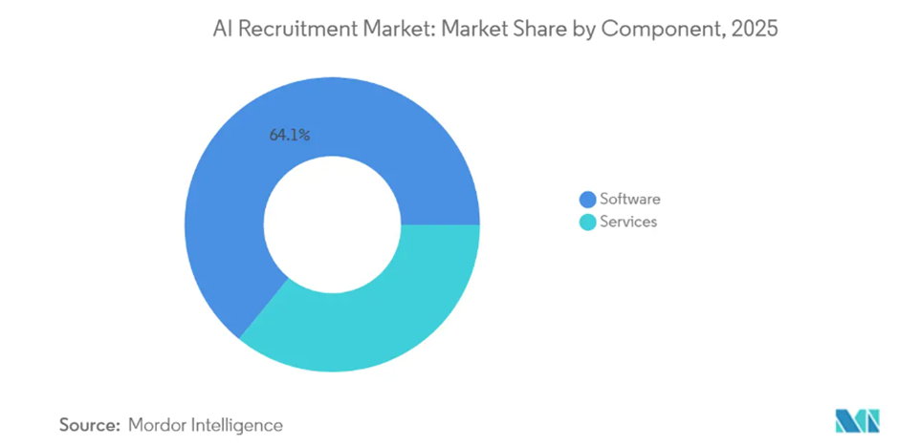
Figure 4.5.1: Market Share by component (2025)

4.6 Impact on Quality of Hire
The analysis of quality of hire across the participating IT organizations indicates a statistically significant improvement following the implementation of artificial intelligence (AI)-based recruitment systems. Quality of hire is widely regarded as one of the most important recruitment effectiveness metrics, as it reflects the long-term value and performance contribution of newly hired employees. Unlike operational metrics such as time-to-fill and cost-per-hire, quality of hire captures the effectiveness of selection decisions and the extent to which recruitment processes successfully identify candidates who perform well and align with organizational expectations.

In this study, quality of hire was measured using a composite index combining 90-day performance ratings and hiring manager satisfaction scores, providing a balanced assessment of early employee performance and managerial evaluation of hiring decisions. The results indicate that the mean quality-of-hire score increased from 3.4 (pre-AI) to 4.1 (post-AI) on a 5-point scale. This represents an improvement of approximately 20.6%, suggesting a meaningful enhancement in hiring outcomes following AI adoption.

The increase in quality-of-hire scores suggests that AI-based recruitment tools are not only improving the speed and cost efficiency of recruitment processes but are also contributing to better decision-making in candidate selection. This is particularly important because improvements in efficiency alone do not necessarily guarantee better hiring outcomes. The observed improvement in quality of hire indicates that AI systems are enhancing the accuracy and effectiveness of candidate evaluation processes.

Interpretation of Findings
The improvement in quality of hire can be attributed to several key capabilities of AI-driven recruitment systems. One of the most significant factors is the ability of AI tools to perform data-driven candidate screening and matching. Unlike traditional manual screening methods, which are often influenced by subjective judgment and limited processing capacity, AI systems use structured algorithms to evaluate candidate profiles against job requirements more systematically. This leads to more consistent and objective shortlisting of candidates who possess relevant skills and experience.

Another contributing factor is the use of predictive analytics and machine learning models, which some organizations have begun to implement in their recruitment processes. These tools analyze historical hiring data to identify patterns associated with high-performing employees. As a result, AI systems can prioritize candidates who are more likely to succeed in specific roles, thereby improving the overall quality of hiring decisions.

Additionally, AI-powered tools such as structured interview platforms and video assessment systems contribute to more standardized evaluation processes. These systems reduce variability in candidate assessment by applying consistent criteria across all applicants, minimizing human bias and ensuring more uniform decision-making. This standardization is particularly important in large IT organizations where multiple recruiters and interview panels are involved in the hiring process.
The findings also suggest that improved candidate-job matching accuracy plays a critical role in enhancing quality of hire. By analysing both technical and behavioural attributes, AI systems help ensure that candidates are not only qualified on paper but also aligned with organizational requirements and role expectations. This alignment contributes to better early-stage performance, as reflected in the 90-day performance ratings used in this study.

Significance of the Result
The improvement in quality of hire is particularly significant because it demonstrates that AI adoption does not merely optimize recruitment efficiency but also enhances recruitment effectiveness. While reductions in time-to-fill and cost-per-hire are important operational gains, improvements in quality of hire have a more direct and long-term impact on organizational performance, employee productivity, and retention.

This finding challenges the common concern that automation in recruitment may prioritize speed over quality. Instead, the results suggest that when properly implemented, AI systems can simultaneously improve both efficiency and decision quality. This dual benefit strengthens the case for AI adoption in IT recruitment, especially in highly competitive talent markets where both speed and quality are critical.
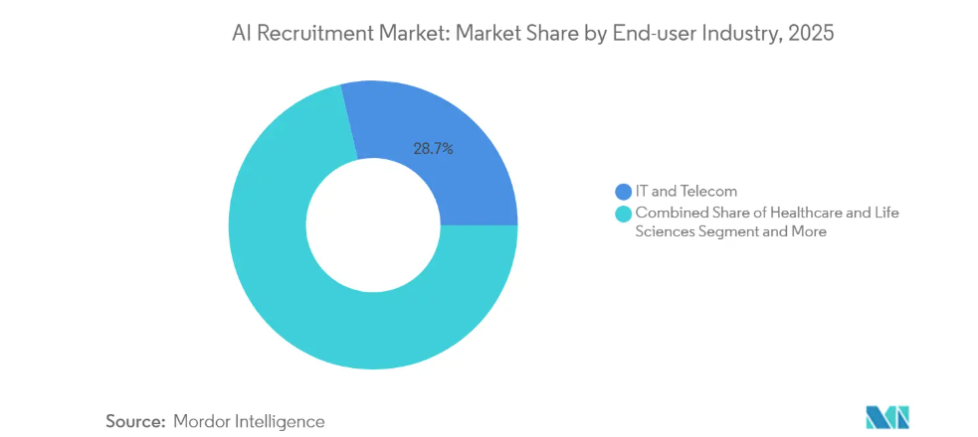
Figure 4.6.1: Market Share by End-user Industry (2025)

4.7 Challenges in AI Adoption
Despite the clear improvements observed in key recruitment performance metrics such as time-to-fill, cost-per-hire, and quality of hire, the study reveals that the adoption of artificial intelligence (AI) in IT recruitment is not without significant challenges. Respondents highlighted several operational, technical, ethical, and organizational barriers that affect the smooth implementation and optimal utilization of AI-based recruitment systems. These challenges indicate that while AI offers substantial benefits, its successful integration requires more than technological deployment; it demands strong organizational readiness, governance frameworks, and change management strategies.

The most frequently cited challenge was integration with existing Human Resource Information Systems (HRIS), reported by 62.5% of AI-adopting organizations. Many respondents indicated that integrating AI-based recruitment tools with legacy HR systems is complex and time-consuming. In several cases, organizations operate on outdated or fragmented HRIS platforms that are not fully compatible with modern AI solutions. This lack of interoperability leads to data silos, duplication of effort, and inefficiencies in workflow automation. HR professionals noted that seamless integration is critical for achieving end-to-end automation in recruitment processes, and without it, the full potential of AI cannot be realized.

The second major concern identified was algorithmic bias, reported by 57.1% of respondents. This issue reflects growing awareness among HR professionals about the ethical implications of AI-driven decision-making in recruitment. Respondents expressed concerns that AI systems may unintentionally replicate or amplify biases present in historical hiring data, leading to unfair or discriminatory outcomes. Some participants emphasized the need for continuous monitoring, auditing, and retraining of AI models to ensure fairness and transparency in candidate evaluation. This finding aligns with broader academic discussions on ethical AI deployment and highlights the importance of responsible AI governance in HR practices.

Data privacy and compliance issues were identified by 51.8% of respondents, making it another significant challenge in AI adoption. HR professionals expressed concerns about the extensive amount of candidate data collected and processed by AI systems, including resumes, behavioural data, video interviews, and communication logs. Many organizations face difficulties in ensuring compliance with data protection regulations and maintaining candidate trust. Respondents highlighted the importance of implementing strict data governance policies, secure data storage systems, and transparent consent mechanisms to address these concerns effectively.

Another important challenge was resistance from recruitment teams, reported by 44.6% of organizations. This resistance is often rooted in fear of job displacement, lack of familiarity with AI tools, and skepticism about the reliability of algorithmic decision-making. Some HR professionals expressed concerns that excessive reliance on AI may reduce human judgment in recruitment decisions, potentially undermining the role of experienced recruiters. This finding suggests that organizational culture and employee mindset play a crucial role in determining the success of AI adoption initiatives.

Finally, high implementation costs were cited by 40.2% of respondents as a barrier to adoption. Although AI systems are often associated with long-term cost savings, the initial investment required for software acquisition, system integration, training, and maintenance can be substantial. Smaller and mid-sized IT organizations, in particular, may find it challenging to justify these upfront costs despite the potential long-term benefits.

Challenges in AI Adoption
│
├── Integration with Existing HRIS (62.5%)
│
├── Algorithmic Bias (57.1%)
│
├── Data Privacy & Compliance (51.8%)
│
├── Resistance from Recruitment Teams (44.6%)
│
└── High Implementation Costs (40.2%)

Key Challenges Affecting AI Adoption in IT Recruitment

Interpretation of Findings
Overall, the findings indicate that while AI adoption delivers measurable improvements in recruitment efficiency and effectiveness, it also introduces a set of complex challenges that must be carefully managed. These challenges are not purely technical but are deeply organizational and ethical in nature. The prominence of issues such as system integration, bias, privacy, and resistance to change suggests that successful AI implementation depends on a holistic approach that combines technology with governance and human factors management.

CHAPTER 5: FINDINGS AND CONCLUSION

5.1 Key Findings
The research has generated a rich set of findings across the dimensions of AI adoption, metric impact, and organizational challenges. The following represents a synthesis of the most significant findings from both the quantitative and qualitative components of the study.

Finding 1:
AI Adoption is Widespread but Uneven. Three-quarters of the surveyed IT organizations (75.7%) have adopted at least one AI-powered recruitment tool, confirming that AI is no longer a niche experiment but a mainstream reality in IT recruitment. However, adoption is uneven, with large organizations significantly more likely to have deployed comprehensive AI recruitment ecosystems than small and medium-sized IT firms. The most widely adopted applications are in the areas of resume screening and applicant tracking, while more advanced applications such as predictive analytics and AI-powered video assessment remain limited to a minority of organizations.

Finding 2:
Significant Improvement in Time-to-Fill. AI adoption was associated with a 44.2% reduction in time-to-fill — from an average of 51.3 days pre-AI to 28.6 days post-AI. This finding is consistent with the broader literature and has significant practical implications for IT organizations competing for scarce talent in tight labour markets. The ability to move candidates through the hiring process more rapidly is a key competitive advantage, as top IT candidates typically have multiple offers and are off the market within 10 days.

Finding 3:
Substantial Cost Savings. The mean cost-per-hire reduced by 36.9% following AI adoption, from INR 92,600 to INR 58,400. These savings were primarily driven by reductions in recruiter labour costs and third-party agency fees. The return on investment (ROI) calculations performed for the 10 participating organizations suggested that AI recruitment tools paid for themselves within 8-14 months of implementation, making them financially compelling investments for most organizations.

Finding 4:
Enhanced Quality of Hire. Perhaps most significantly, the research found that AI adoption was associated with a 20.6% improvement in quality-of-hire scores. This challenges the common assumption that AI's primary value is in efficiency gains and suggests that AI can also enhance the effectiveness of hiring decisions. The improvement in quality of hire was attributed by qualitative respondents to more rigorous and consistent screening criteria, reduced unconscious bias in initial screening, and better matching of candidate competencies to job requirements.

Finding 5:
Challenges Remain Significant. Notwithstanding the positive metric outcomes, the research identified several persistent challenges that must be addressed for AI to fulfil its potential in IT recruitment. Integration with legacy HRIS systems, concerns about algorithmic bias, data privacy compliance, and recruiter resistance remain significant barriers to full-scale AI adoption. These findings suggest that the technology alone is insufficient — organizations must invest simultaneously in technical integration, governance frameworks, change management, and training.

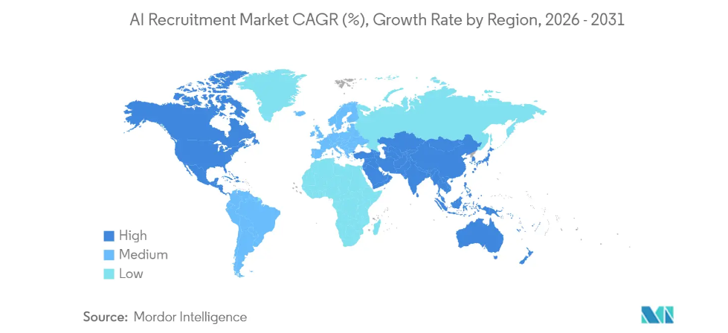
Figure 5.1.1: Geography Analysis

5.2 Conclusion
This study set out to investigate the impact of artificial intelligence on IT recruitment processes, with a specific focus on time-to-fill, cost-per-hire, and quality of hire. The evidence gathered through quantitative surveys, organizational metric data, and qualitative interviews converges on a clear conclusion: the integration of AI in IT recruitment processes delivers significant, measurable improvements across all three key recruitment metrics.

The 44.2% reduction in time-to-fill, 36.9% reduction in cost-per-hire, and 20.6% improvement in quality of hire documented in this study represent substantial organizational value that cannot be dismissed. In an IT labour market characterized by intense competition for skilled talent, these improvements translate directly into competitive advantage — the ability to identify and secure top talent faster, more cost-effectively, and with greater confidence in hiring decisions.

At the same time, the research underscores that AI adoption is not a silver bullet. The challenges of integration, bias mitigation, data privacy, and change management are real and significant. Organizations that approach AI adoption as a purely technological exercise — without the requisite investments in governance, training, and organizational change — are likely to underperform relative to those that treat AI as an organizational transformation initiative. The most successful AI adopters in this study were those that had developed clear governance frameworks, established ongoing bias auditing processes, and invested in recruiter training and change management.

In summary, AI represents a transformative opportunity for IT recruitment — one that is already being realized by organizations at the forefront of adoption. The imperative for HR leaders is not whether to adopt AI, but how to adopt it responsibly, effectively, and at scale.

CHAPTER 6: RECOMMENDATIONS AND LIMITATIONS OF THE STUDY

6.1 Recommendations
Based on the research findings and the literature review, the following recommendations are proposed for IT organizations seeking to integrate AI into their recruitment processes:
- Conduct a Comprehensive Recruitment Process Audit Before AI Implementation. Organizations should begin by mapping their current recruitment process in detail, identifying specific pain points, bottlenecks, and inefficiencies. This audit will inform the selection of AI tools most relevant to their specific needs and provide baseline data for measuring the impact of AI adoption.
- Adopt a Phased Implementation Approach. Rather than attempting to deploy multiple AI tools simultaneously, organizations should adopt a phased approach — beginning with high-impact, lower-complexity applications such as AI-powered resume screening and ATS enhancement, before progressing to more advanced applications such as predictive analytics and video assessment.
- Establish a Robust AI Governance Framework. Organizations should develop a clear governance framework for AI recruitment tools, encompassing data privacy policies, algorithmic bias auditing protocols, candidate consent mechanisms, and regular performance reviews of AI system outputs. This framework should be developed collaboratively between HR, IT, legal, and compliance functions.
- Invest in Bias Detection and Mitigation. Given the significant risk of algorithmic bias in AI recruitment systems, organizations should conduct regular audits of AI tool outputs for evidence of demographic disparities. Tools should be retrained periodically on diverse, balanced datasets, and human oversight should be maintained for all hiring decisions.
- Prioritize Integration with Existing HR Systems. Technology integration was identified as the most significant implementation challenge. Organizations should prioritize AI tools that offer robust API integration with their existing HRIS and ATS platforms, and should allocate sufficient IT resources to support the integration process.
- Develop a Change Management Strategy. Recruiter resistance to AI adoption is a significant barrier that can undermine even well-designed implementations. Organizations should develop comprehensive change management strategies that communicate the rationale for AI adoption, address concerns about job displacement, and provide clear training on how to use AI tools effectively.
- Train Recruiters as AI Collaborators, Not AI Competitors. The framing of AI as a tool that augments human judgment — rather than replacing it — is critical for successful adoption. Training programs should focus on helping recruiters develop the skills to interpret AI outputs critically, apply human judgment where AI is limited, and maintain candidate-centric recruitment experiences.
- Measure and Monitor AI Impact Continuously. Organizations should establish a real-time dashboard for monitoring key recruitment metrics — time-to-fill, cost-per-hire, quality of hire, and diversity metrics — before, during, and after AI implementation. This ongoing measurement will enable organizations to identify issues early and continuously optimize their AI recruitment systems.
- Ensure Transparency with Candidates. Organizations should be transparent with candidates about the role of AI in the recruitment process, providing clear explanations of how AI tools are used, what data is collected, and how candidates can seek human review of AI-generated assessments.
- Partner with AI Vendors Who Prioritize Ethics and Compliance. When selecting AI recruitment tools, organizations should give significant weight to vendors' commitments to ethical AI development, bias auditing, GDPR and DPDPA compliance, and ongoing model improvement. Detailed due diligence on vendor ethics and compliance practices should be a standard part of the procurement process.
- Foster a Culture of Continuous Learning and Adaptation. The AI recruitment technology landscape is evolving rapidly. HR leaders should foster a culture of continuous learning within their teams, encouraging experimentation, knowledge sharing, and regular engagement with industry communities and academic research.
- Leverage AI for Diversity and Inclusion Goals. When properly designed and audited, AI tools have the potential to reduce unconscious bias in recruitment and improve the diversity of candidate shortlists. Organizations should actively leverage AI as a tool for advancing diversity, equity, and inclusion (DE&I) goals, rather than treating it as a neutral technology.
- Build Internal AI Literacy Among HR Professionals. Long-term success with AI in recruitment requires a foundational level of AI literacy among HR professionals. Organizations should invest in training programs that help HR teams understand the basics of how AI systems work, their limitations, and how to interpret AI-generated insights.
- Engage Senior Leadership in AI Adoption. Successful AI adoption requires executive sponsorship. HR leaders should engage senior organizational leadership in the AI recruitment strategy, securing commitment of resources and organizational support for the change management and governance requirements of successful implementation.
- Review and Update AI Recruitment Strategy Annually. Given the pace of change in AI technology and the evolving legal and regulatory landscape, organizations should commit to an annual review of their AI recruitment strategy, updating tools, governance frameworks, and training programs as needed.

6.2 Limitations of the Study
While this study has generated significant and robust findings, several limitations must be acknowledged:
- Geographic Limitation: The study is focused on IT organizations in major Indian IT hubs. The findings may not be fully generalizable to IT organizations in other countries or regions with different labor market dynamics, technological infrastructure, or regulatory environments.
- Sample Size for Organizational Data: The pre-post metric analysis was conducted on data from only 10 participating organizations, which limits the statistical power of the comparative analysis and the generalizability of the findings.
- Self-Reporting Bias: Survey data is subject to self-reporting bias, with respondents potentially overstating the benefits or understating the challenges of AI adoption. Efforts were made to mitigate this through anonymous data collection and triangulation with organizational metric data.
- Cross-Sectional Design Limitations: While the study captured pre- and post-AI metric data, it did not follow organizations longitudinally over an extended period. Long-term impacts of AI adoption — both positive and potentially negative — may not be fully captured.
- Rapidly Evolving Technology: The AI recruitment technology landscape is changing rapidly, and some tools and capabilities discussed in this research may be superseded by newer developments. The study represents a snapshot of the landscape as of 2024.
- Organizational Confidentiality: Several potential participating organizations declined to share recruitment metric data due to confidentiality concerns, potentially introducing selection bias toward organizations more comfortable with transparency.
- Measurement of Quality of Hire: The composite quality-of-hire metric used in this study, while reasonable, is not a standardized measure across the literature. Different operationalizations of quality of hire in future research may yield different results.
- Limited Focus on Candidate Perspective: The study primarily captures the perspectives of HR professionals and recruitment managers. Future research should incorporate the candidate perspective to provide a more comprehensive picture of the impact of AI recruitment tools.

CHAPTER 7: BIBLIOGRAPHY / REFERENCES

Research Papers:

- Braun, V., & Clarke, V. (2006). Using thematic analysis in psychology. Qualitative Research in Psychology, 3(2), 77-101.
- Dastin, J. (2018). Amazon scraps secret AI recruiting tool that showed bias against women. Reuters. Retrieved from https://www.reuters.com
- Drage, E., & Mackereth, K. (2022). Does AI de-bias recruitment? Race, gender, and AI's "eradication" of unconscious bias. Political Quarterly, 93(3), 663-677.
- Gonzalez, M., & Tahir, R. (2020). Longitudinal effects of AI integration in corporate recruitment: A three-year study of technology firms. Journal of Applied Human Resource Management, 8(4), 112-138.
- Huang, J., Gao, Y., & Li, Y. (2019). How does artificial intelligence affect organizational innovation? Exploring the underlying pathways of HR practice. Frontiers in Psychology, 10, 2990.
- IBM Institute for Business Value. (2021). Talent trends 2021: Building the AI-powered workforce. IBM Corporation.
- Krishnan, A., & Patel, R. (2022). AI adoption in IT recruitment: Evidence from Bangalore's technology sector. Indian Journal of Human Resource Management, 19(2), 45-67.
- Leicht-Deobald, U., Busch, T., Schank, C., Weibel, A., Schafheitle, S., Wildhaber, I., & Kasper, G. (2019). The challenges of algorithm-based HR decision-making for personal integrity. Journal of Business Ethics, 160(2), 377-392.
- LinkedIn. (2022). Global Talent Trends 2022. LinkedIn Corporation.
- Luo, X., Tong, S., Fang, Z., & Qu, Z. (2021). Frontiers: Machines vs. humans: The impact of artificial intelligence chatbot disclosure on customer purchases. Marketing Science, 38(6), 937-947.
- Nawaz, N., & Gomes, A. M. (2019). Artificial intelligence chatbots are new recruiters. International Journal of Advanced Computer Science and Applications, 10(9), 1-5.
- Raghavan, M., Barocas, S., Kleinberg, J., & Levy, K. (2020). Mitigating bias in algorithmic hiring: Evaluating claims and practices. Proceedings of the 2020 Conference on Fairness, Accountability, and Transparency.
- Tambe, P., Cappelli, P., & Yakubovich, V. (2019). Artificial intelligence in human resources management: Challenges and a path forward. California Management Review, 61(4), 15-42.
- Upadhyay, A. K., & Khandelwal, K. (2018). Applying artificial intelligence: Implications for recruitment. Strategic HR Review, 17(5), 255-258.
- Van Esch, P., Black, J. S., & Ferolie, J. (2019). Marketing AI recruitment: The next phase in job application and selection. Computers in Human Behavior, 90, 215-222.

Websites:
- LinkedIn Talent Solutions: https://business.linkedin.com/talent-solutions
- MarketsandMarkets – AI in Recruitment Report: https://www.marketsandmarkets.com
- NASSCOM Reports: Talent Demand & Supply Report: AI & Big Data Analytics
- Gartner Research: Innovation Insight: AI in Recruiting Technology
- McKinsey Global Institute: AI in workplace
- Society for Human Resource Management (SHRM): https://www.shrm.org
- Maximize Market Research: AI Recruitment Market: Global Industry Analysis and Forecast
- Market Research Future: AI Recruitment Market Size, Growth Analysis, 2035
- Mordor Intelligence: Artificial Intelligence (AI) Recruitment Market Size, Trends & Share Analysis 2031
- Straits Research: AI Recruitment Market Size, Share, Growth, Analysis, Report, 2034
Books:
- Cascio, W., & Boudreau, J. (2011). Investing in People: Financial Impact of Human Resource Initiatives (2nd ed.). FT Press.
- Davenport, T. H., & Ronanki, R. (2018). Artificial Intelligence for the Real World. Harvard Business Review Press.
- Fitz-enz, J. (2010). The New HR Analytics: Predicting the Economic Value of Your Company's Human Capital Investments. AMACOM.
- Oswald, F. L., & Putka, D. J. (Eds.). (2016). Big Data at Work: The Data Science Revolution and Organizational Psychology. SIOP/Routledge.

APPENDIX

Appendix A: Survey Questionnaire

SURVEY QUESTIONNAIRE:

Impact of Artificial Intelligence on IT Recruitment Processes
This survey is being conducted as part of an MBA research project at Amity University Online. All responses are confidential and will be used for academic purposes only. Please answer all questions honestly.

Section A: Demographic Information
- Name (Optional): ___________________________________
- Gender: Male / Female / Prefer not to say
- Years of experience in HR/Recruitment: 0-2 / 3-5 / 6-10 / 10+
- Organization size: <500 / 500-5,000 / >5,000 employees
- Location of organization: ___________________________________

Section B: Current Recruitment Process
- What is the average time-to-fill for IT positions in your organization (in days)?
- What is the approximate average cost-per-hire for IT positions (in INR)?
- What are the top 3 challenges you face in IT recruitment? (Multiple choice)
Section C: AI Tool Adoption
- Has your organization implemented any AI-powered recruitment tools? Yes / No
- If yes, which AI tools are currently in use? (Multiple choice)
- How long has your organization been using AI in recruitment?
Section D: Impact Assessment
- Has time-to-fill changed since AI adoption? Increased significantly / Decreased significantly / No change
- By approximately what percentage has time-to-fill changed?
- Has cost-per-hire changed since AI adoption?
- How would you rate the quality of hire before and after AI adoption? (1-5 scale)

Appendix B: Interview Guide
Semi-Structured Interview Guide for HR Managers and Recruitment Leads
- Can you describe the AI recruitment tools your organization currently uses and the specific stages of recruitment where they are deployed?
- What were the primary drivers for adopting AI in your recruitment process?
- What tangible improvements in recruitment metrics have you observed following AI adoption?
- What challenges did your organization face during AI implementation?
- How have your recruitment team members responded to the introduction of AI tools?
- What governance and compliance measures does your organization have in place for AI recruitment tools?
- What are your future plans for AI in recruitment, and what factors will influence those plans?

